Pulleys and Wedges
Please remember to photocopy 4 pages onto one sheet by going A3→A4 and using back to back on the photocopier

This booklet contains every higher level (and most ordinary level) questions that have appeared on exam papers from 1971 – 2023
Note that this topic was usually Question 4 on the old syllabus (up to 2022)
Fully worked solutions from the legend that is Dominick Donnelly here appliedmathematics.ie/index.php/students/exam-solutions
Solutions to HL 2023 and Sample Paper (plus lots more) from Joe Kennedy here: https://www.jkmaths.net/exam-paper-solutions
Screencasts of worked solutions to HL 2023 and Sample Paper (plus lots more) from Shane Molloy here: https://www.molloymaths.com/applied-maths

Exam Papers (in pdf and Word format) plus Marking Schemes (and lots more) from: thephysicsteacher.ie/exammaterialappliedmaths.html
A good idea is to look at as many sources as you can for solutions as there is often more than one approach and some can be much easier to understand and/or remember than others.
Screencasts of worked solutions to various older past paper question plus comprehensive resources for all topics

Questions from 2023 and Sample Paper (Ordinary level and Higher level) are left until the very end – page 37

You can find this document plus all other Applied Maths booklets on the homepage of thephysicsteacher.ie

Last updated: 04/11/2023
Noel Cunningham

Contents
Introduction 2
Reaction force 2
Pulleys – ordinary level worked solutions 3
Pulleys: Ordinary Level Exam Questions 5
Friction – a sticky force. 7
Ordinary level exam questions involving friction 8
Three Particles 9
Questions involving equations of motion (vuast) 11
Questions involving conservation of momentum 13
Movable Pulleys 15
Ordinary Level 20
Ordinary level exam questions 23
Wedges – Higher Level 26
Pulleys and Wedges: Answers to Ordinary Level Exam Questions 30
Pulleys and Wedges: Answering Higher Level Exam Questions 33
Pulleys & Wedges questions from 2023 and Sample Paper: Ordinary level and Higher level 37

Introduction

In all of these problems we want to apply Newton’s Second Law (F = ma) to each object.

- Use BIG diagrams!

- Draw a force diagram for each object separately (decide a sign convention for each object and then be consistent).

- Don’t forget to include arrows.

- Note the mass of each object.

- Draw in the acceleration of each object (be careful to allow for relative acceleration).

- Draw the acceleration off to the side so that an examiner doesn’t think you are treating it as a force.

- Fill in F = ma for each object and solve the resulting set of equations as required.

Reaction force
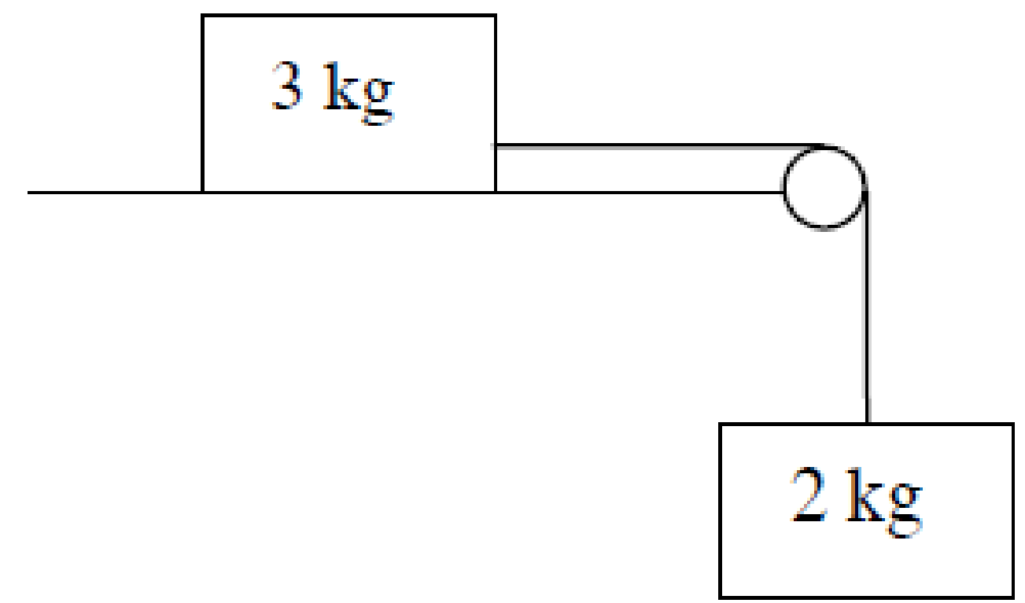
Look at the 3 kg mass sitting on the table.
The force of gravity pulling it down is 3g newtons.
The fact that it isn’t accelerating down must mean that there is an equal and opposite force pushing up.
We call this the reaction force.

Maths teachers and engineers are generally happy to accept this logic and not question it further. A physics student/teacher should never accept any explanation as the complete answer and should always seek a deeper explanation. In this case that questioning will be rewarded in spades.
How does a table ‘push up’?
If the block on top was 4 kg then the table would be pushing up with a force equivalent to 4g newtons.
How does the table ‘know’ how much force to use – after all, if it got it wrong and pushed up with a force of 5g newtons then the block on top would fly up into the air; not a common occurrence.

Pulleys – ordinary level worked solutions

2009 (a) OL
Two particles of masses 3 kg and 2 kg are connected by a taut, light, inextensible string which passes over a smooth light pulley at the edge of a smooth horizontal table.
The system is released from rest.
- Show on separate diagrams the forces acting on each particle.
- Find the common acceleration of the particles.
- Find the tension in the string.

Solution
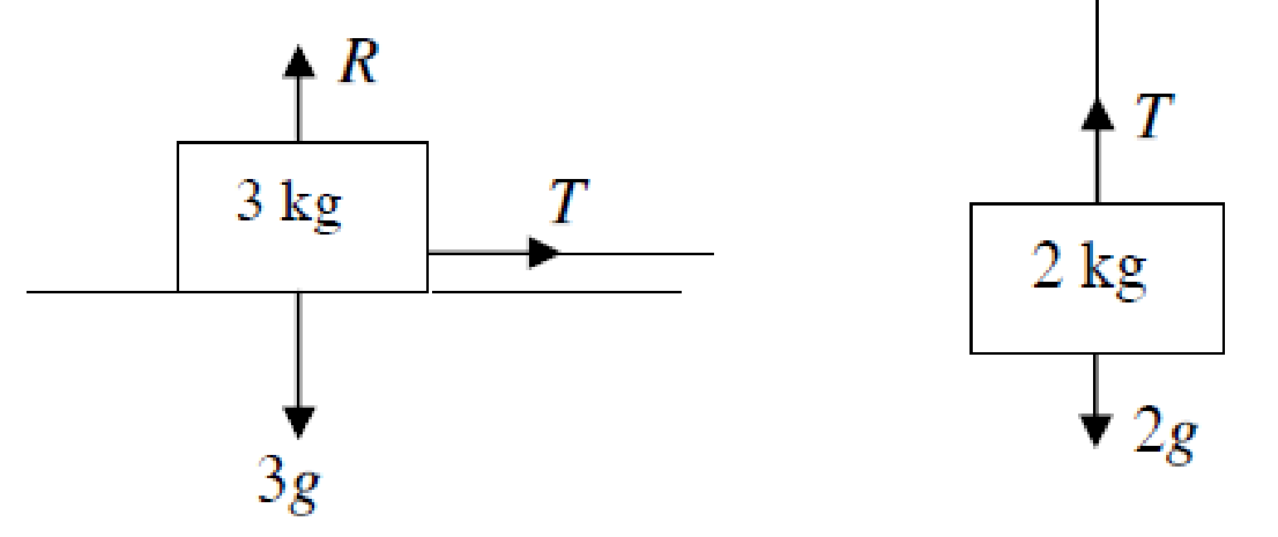
(i)
The particles are connected by a string.
The tension due to the string is the same at both ends (“one string – one tension”) so as the 2 kg particle accelerates downwards the 3 kg particle will accelerate across at the same rate.
We label this tension ‘T’ (because we’re an imaginative bunch we are).

(ii)
For the 3 kg mass: T = 3a
For the 2 kg mass: 2g – T = 2a

Now sub T = 3a into the second equation to get 20 – 3a = 2a [taking g = 10 m s⁻² at ordinary level]
Solve to get a = 4 m s⁻²

(iii)
Now sub this value for a into the T = 3a equation to get T = 12 N

2008 (a) OL
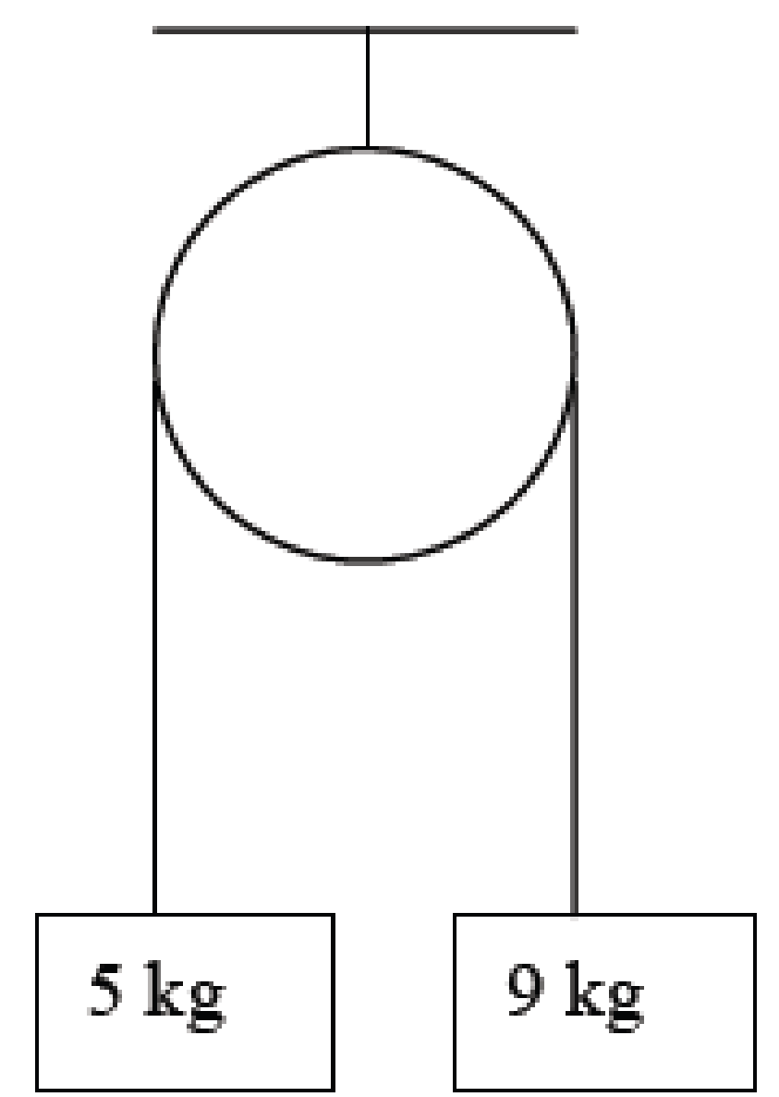
Two particles of masses 9 kg and 5 kg are connected by a taut, light, inextensible string which passes over a smooth light pulley.
The system is released from rest.
Find
- the common acceleration of the particles
- the tension in the string.

Solution
(i) The common acceleration of the particles
Here we need an equation to describe the motion of each of the particles.
So applying F = ma to both masses we get:
T – 5g = 5a and 9g – T = 9a

So we have two simultaneous equations and rearrange them so that similar terms are in the same column:
T – 5g = 5a
-T +9g = 9a
- 4g = 14a ⇒ a = 4g/14 ⇒ a= 2.86 m s⁻² [taking g = 10 m s⁻²]

(ii) The tension in the string.
Here we can substitute our calculated value for a into either of the first two equations.
T – 5g = 5a ⇒ T – 50 = 5(2.86) ⇒ T = 64.29 N
Now try the following questions (all ordinary level, so take g = 10 m s⁻²)

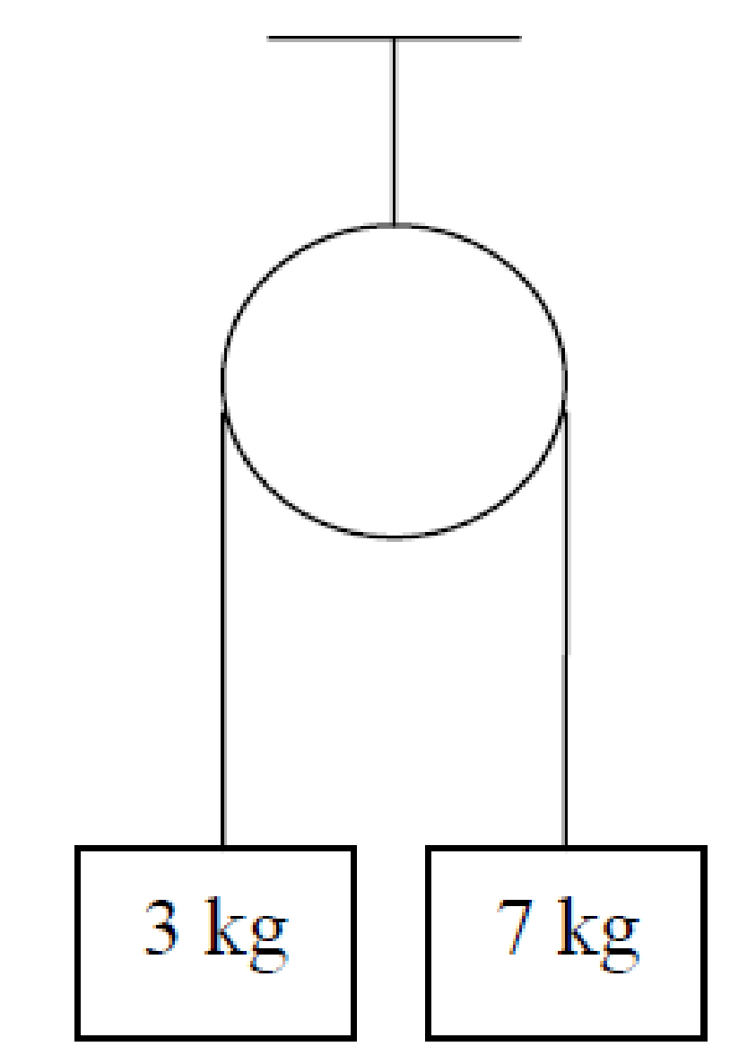
Pulleys: Ordinary Level Exam Questions
2007 (a) OL
Two particles of masses 7 kg and 3 kg are connected by a taut, light, inelastic string which passes over a smooth light pulley.
The system is released from rest.
Find
- the common acceleration of the particles.
- the tension in the string.

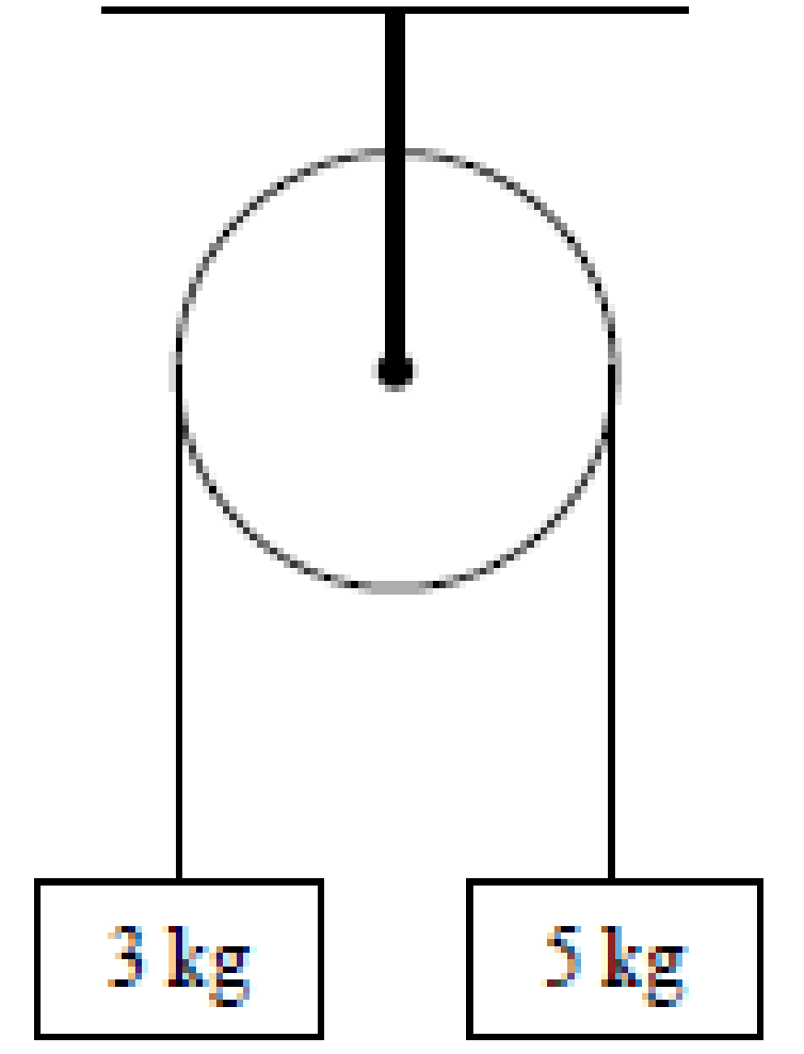
2014 (a) OL
Two particles of masses 3 kg and 5 kg are connected by a taut, light, inextensible string which passes over a smooth light fixed pulley.
The system is released from rest.
Find
- the common acceleration of the particles
- the tension in the string.

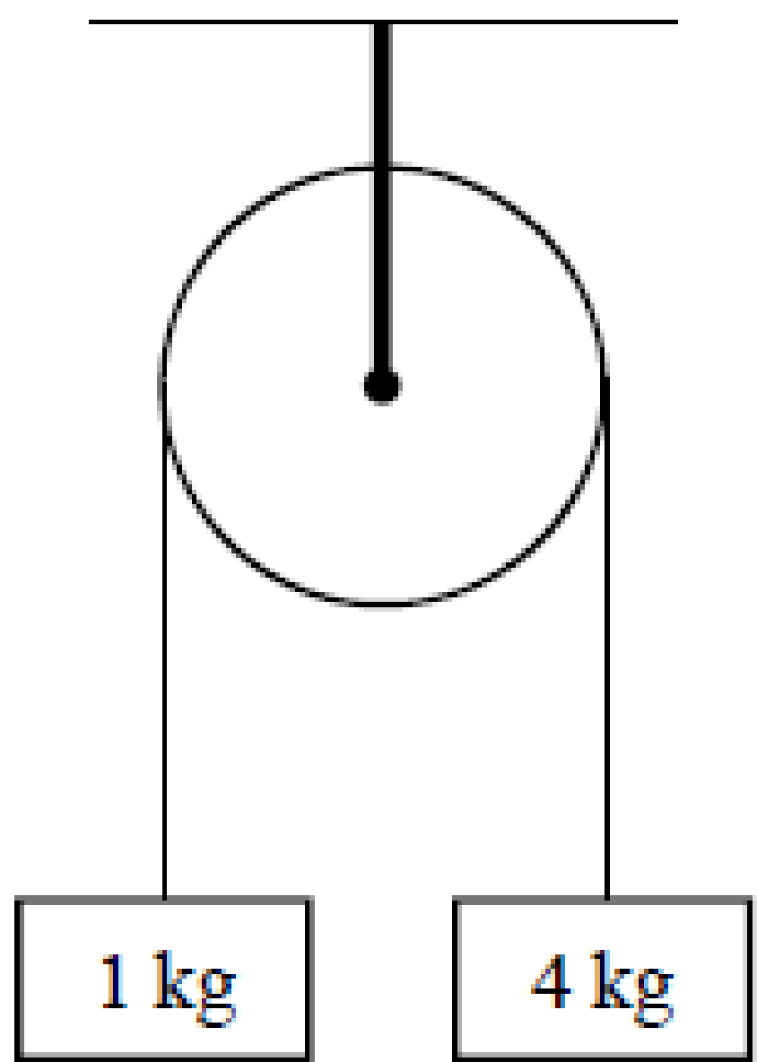
2016 (a) OL
Masses of 1 kg and 4 kg are connected by a taut, light, inextensible string which passes over a smooth light fixed pulley.
The system is released from rest.
- Find the common acceleration of the masses
- Find the tension in the string.

2004 (a) OL
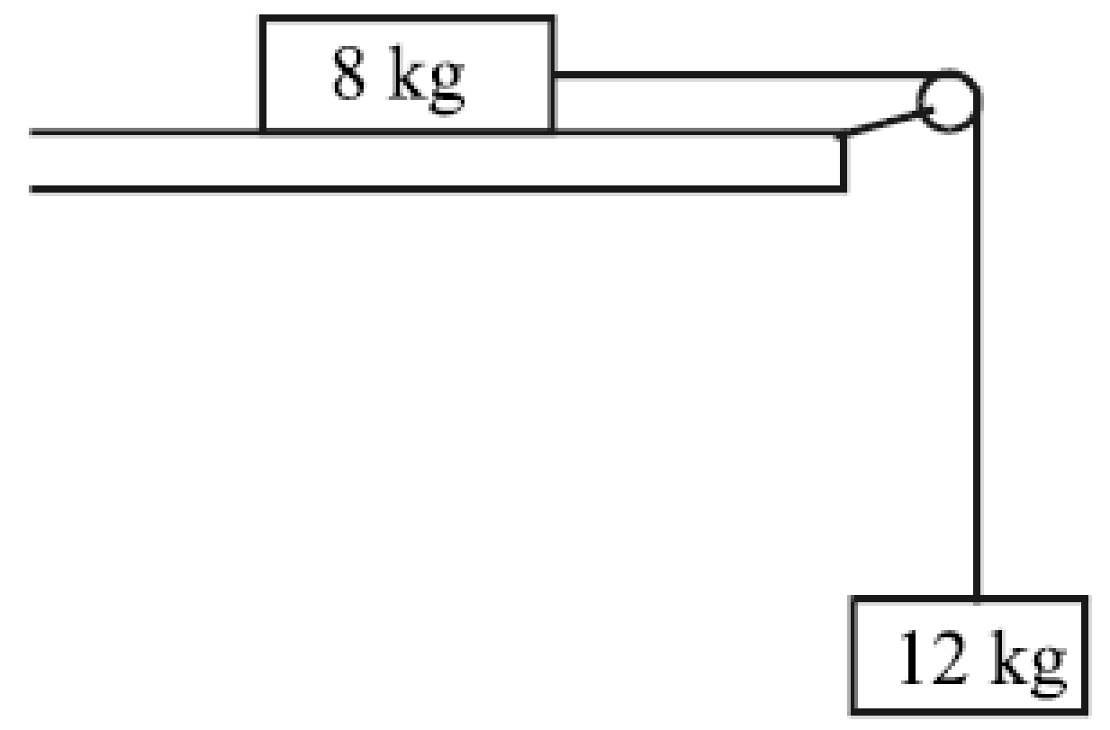
Two particles, of masses 8 kg and 12 kg, are connected by a light, taut, inextensible string passing over a smooth light pulley at the edge of a smooth horizontal table.
The 12 kg mass hangs freely under gravity.
The particles are released from rest.
The 12 kg mass moves vertically downwards.
- Show on separate diagrams all the forces acting on each particle.
- Find the acceleration of the 12 kg mass.
- Find the tension in the string.

2003 (a) (higher level!)
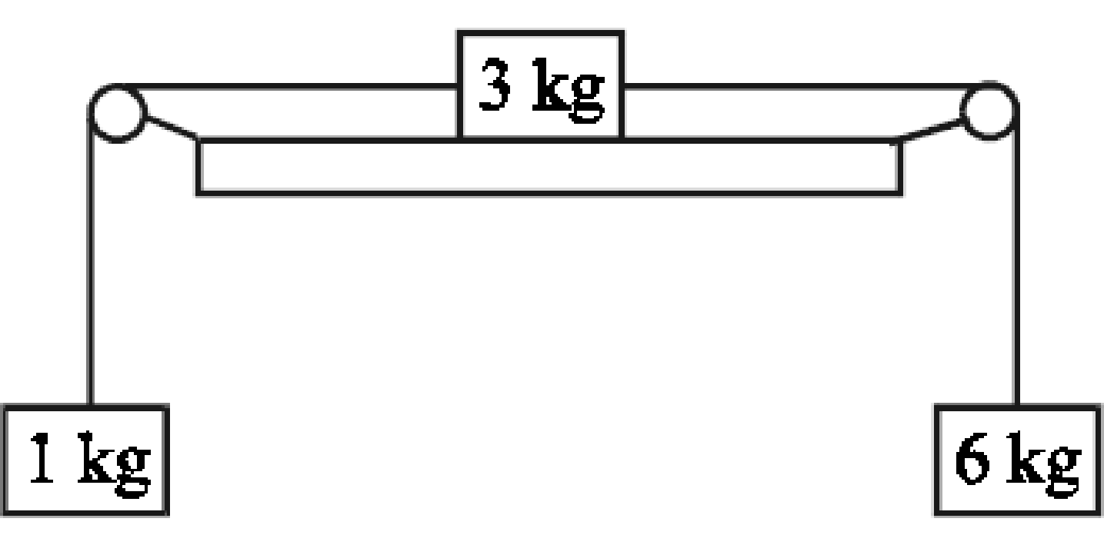
A particle of mass 3 kg rests on a smooth horizontal table and is attached by two light inelastic strings to particles of masses 6 kg and 1 kg which hang over smooth light pulleys at opposite edges of the table.
The system is released from rest.
Find the acceleration of the system, in terms of g.

Trickier Questions {leave these until sixth year}

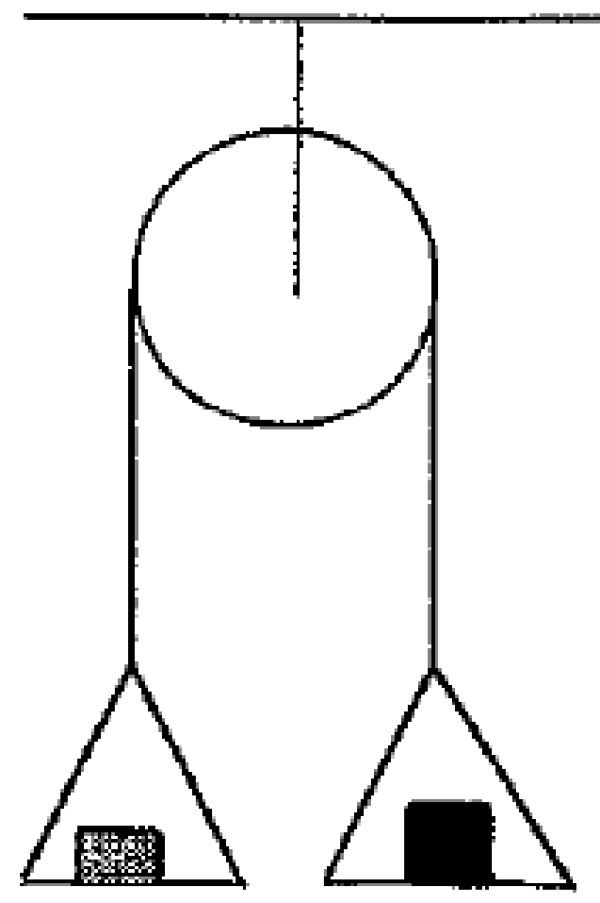
1999 (a) higher level
Two scale-pans each of mass 0.5 kg are connected by a light elastic string which passes over a smooth light fixed pulley.
A mass of 0.2 kg is placed on one pan and a mass of 0.4 kg is placed on the other pan.
The system is released from rest.
Calculate
- the acceleration of the system
- the forces between the masses and the pans.

Here proceed as normal to calculate the acceleration, then for the forces between the masses and the pans simply look at the forces acting on each mass – “the force between the mass and the pan” is simply the reaction force (the force which the pan is exerting on the mass, and from Newton III this is also the force which the mass is exerting on the pan).
0.4 kg: 0.4g – R₁ = 0.4a and solve to get R₁
0.2 kg: R₂ – 0.2g = 0.2a and solve to get R₂

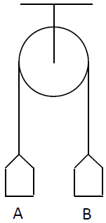
2017 (a)
Two scale pans A and B, each of mass m kg, are attached to the ends of a light inextensible string which passes over a light smooth fixed pulley.
They are held at the same level, as shown in the diagram.
A mass of 3m kg is now placed on A.
The system is released from rest.
Find
- the tension in the string in terms of m
- how far B has risen when it reaches a speed of 0∙4 m s^{–1}
- the reaction on the 3m kg mass in terms of m.

Friction – a sticky force.
As all good physics students know, there are (in this universe at least) only four fundamental forces. For the record these four forces are:
1. Gravitational force
2. Electromagnetic force
3. Strong force
4. Weak force.
Almost all other (everyday) forces are actually just variations on the electromagnetic force.
The electromagnetic force is responsible for the repulsion experienced by electrons, and this lies at the heart of what’s coming next.

Relationship between the friction force and reaction force

$$μ= \frac{Friction force (F_{f})}{Reaction force (R)}$$
Or
F_{f} = μR $0<μ≤1$

If the question uses the term ‘smooth’ then you can assume that there is no friction at play for that surface; where friction is involved the question will either mention it explicitly or alternatively will describe the surfaces as ‘rough’.

2001 (a) OL
Two particles, of masses 18 kg and 9 kg respectively, are connected by a light
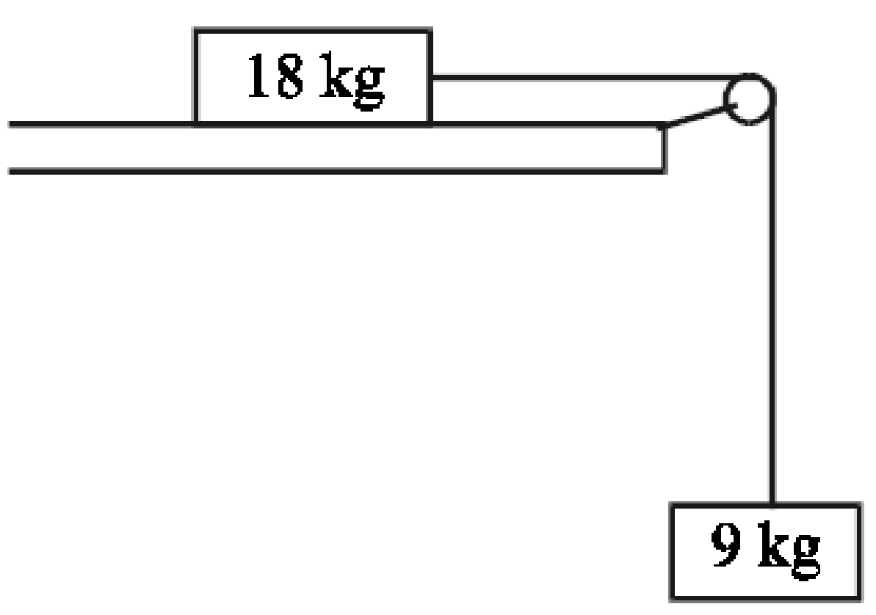
An inextensible string passing over a smooth light pulley at the edge of a rough horizontal table.
The coefficient of friction between the 18 kg mass and the table is μ.
The 9 kg mass hangs freely under gravity.
The particles are released from rest.
The 9 kg mass moves vertically downwards with an acceleration of 5/9 m/s².
- Show on separate diagrams all the forces acting on each particle.
- Find the value of the tension in the string.
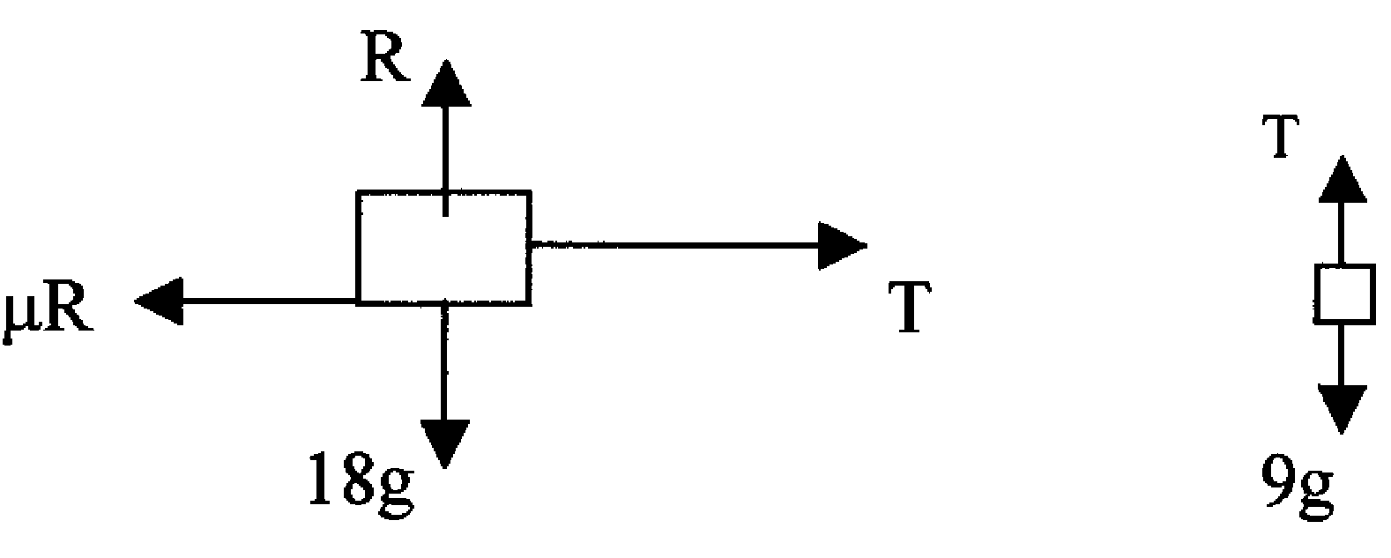
- Find the value of μ, giving your answer as a fraction.

Solution

(i) Forces acting on each particle:

(ii)
We start with the 9 kg particle because we know the most information about it:

9g – T = 9a ⇒ 90 – T = 9(5/9) ⇒ T = 85 N

(iii)
Now for the 18 kg mass we know that in the vertical direction the particle is not accelerating, therefore forces up = forces down, i.e. R = 18g, or R = 180 N.

In the horizontal direction the particle is accelerating to the right, so the equation is:
T – μR = 18a ⇒ 85 – μ(180) = 18(5/9) ⇒ μ = 5/12

Ordinary level exam questions involving friction

2006 (a) OL
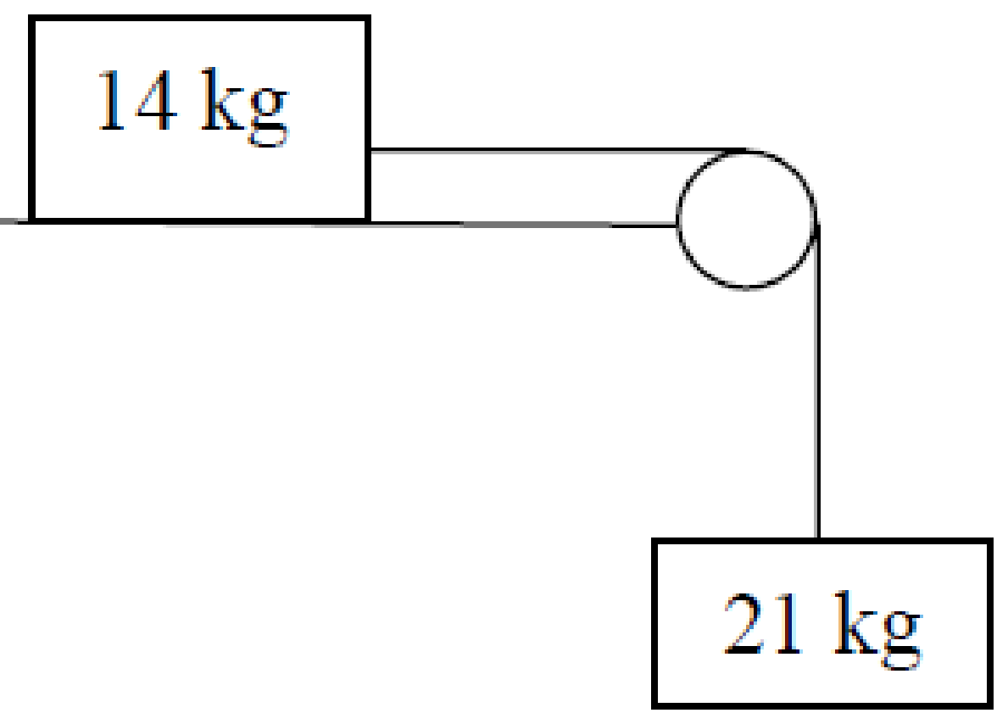
Two particles of masses 14 kg and 21 kg are connected by a light, taut, inextensible string passing over a smooth light pulley at the edge of a rough horizontal table.
The coefficient of friction between the 14 kg mass and the table is ½.
The system is released from rest.
- Show on separate diagrams the forces acting on each particle.
- Find the common acceleration of the particles.

2015 (a) OL
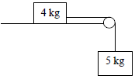
A particle of mass 4 kg is connected to another particle of mass 5 kg by a taut light inelastic string which passes over a light smooth pulley at the edge of a rough horizontal table.
The coefficient of friction between the 4 kg mass and the table is $\frac{3}{4}$.
The system is released from rest.
- Show on separate diagrams the forces acting on each particle.
- Find the common acceleration of the particles.
- Find the tension in the string.

2003 (a) OL
{This one is slightly different in that rather than asking you to calculate the acceleration, it gives you the acceleration and asks you to calculate the unknown mass. Approach the question in the normal manner.}
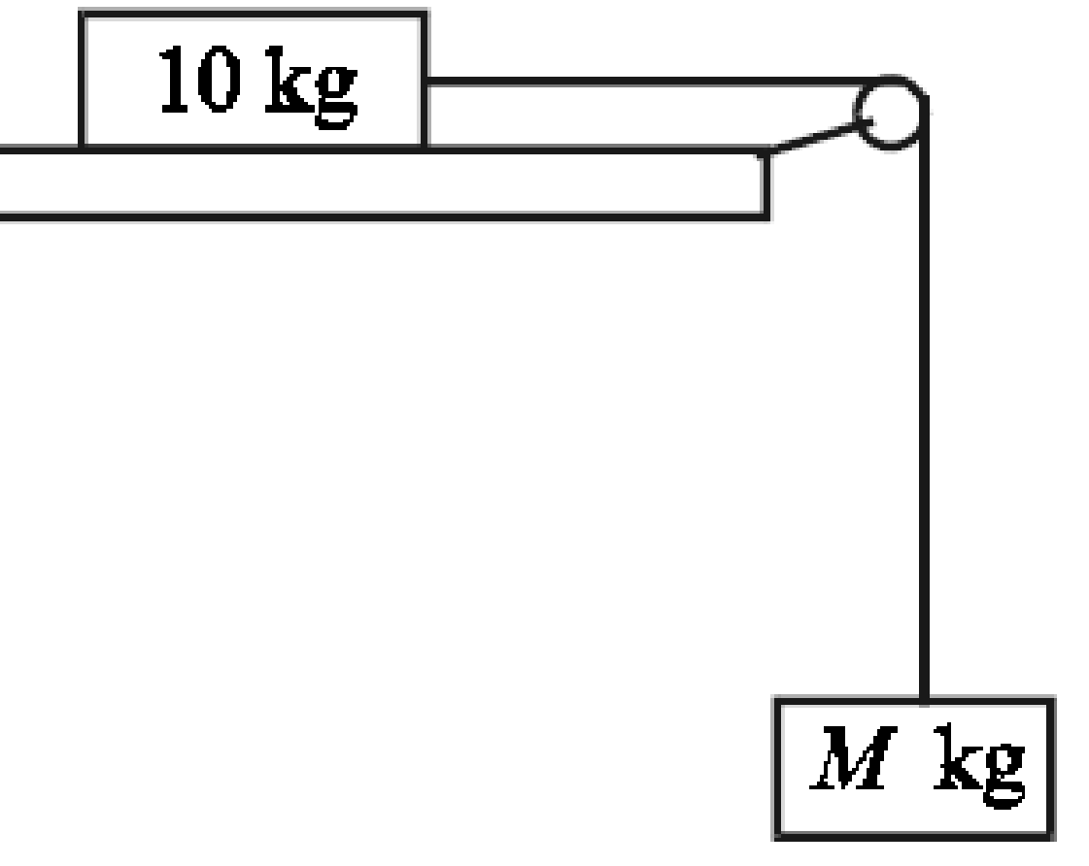
Two particles, of masses 10 kg and M kg, are connected by a light, taut, inextensible string passing over a smooth light pulley at the edge of a rough horizontal table.
The coefficient of friction between the 10 kg mass and the table is ½.
The M kg mass hangs freely under gravity.
The particles are released from rest.
The M kg mass moves vertically downwards with an acceleration of 4 m/s².
- Show on separate diagrams all the forces acting on each particle.
- Find the tension in the string.
- Find the value of M.

2017 (a) OL
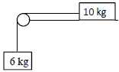
A particle of mass 10 kg is connected to another particle of mass 6 kg by a taut light inelastic string which passes over a smooth light pulley at the edge of a rough horizontal table.
The coefficient of friction, µ, between the 10 kg mass and the table is $\frac{2}{5}$ .
The system is released from rest.
- Show on separate diagrams the forces acting on each particle.
- Find the common acceleration of the particles.
- Find the tension in the string.
- Comment on the motion of the system if µ ≥ $\frac{3}{5}$.

Three Particles
2002 OL (full question)
Particles, of masses 2 kg and 3 kg, resting on a rough horizontal table, are connected by a light taut inextensible string.
The coefficient of friction between the 2 kg mass and the table is 1/8 and between the 3 kg mass and the table is 1/4.
The 3 kg mass is connected by a second light inextensible string passing over a smooth light pulley at the edge of the table to a particle of mass 5 kg.
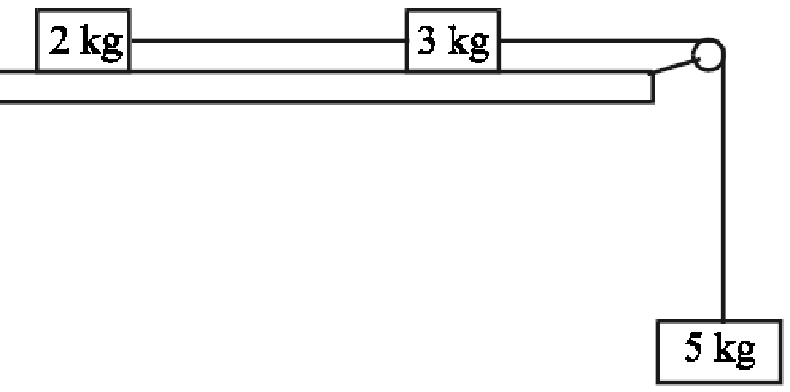
The 5 kg mass hangs freely under gravity.
The particles are released from rest.
The 5 kg mass moves vertically downwards.
- Show on separate diagrams all the forces acting on each particle.
- Write down the equation of motion for each particle.
- Find the common acceleration of the particles and the tension in each string.

Solution
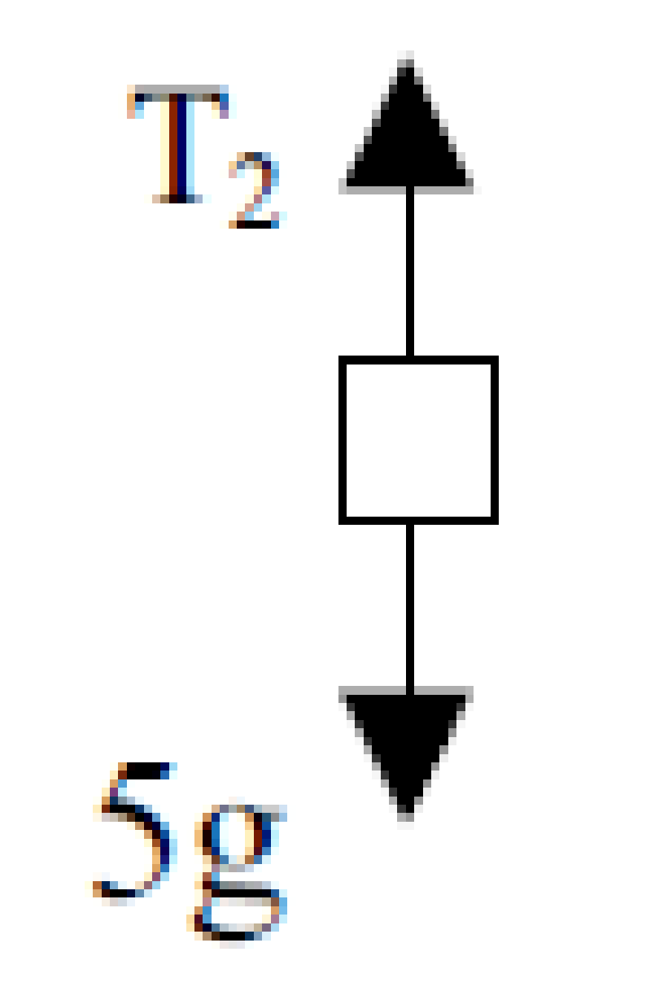
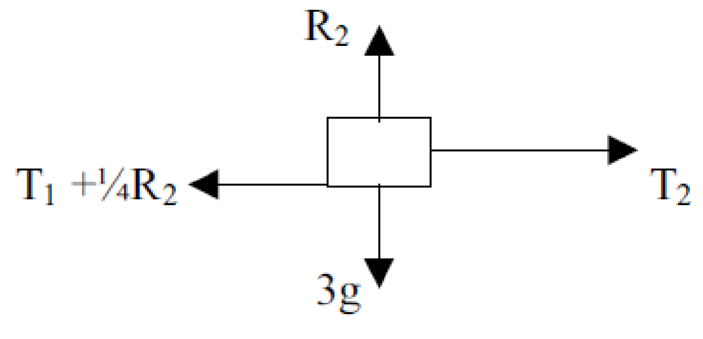
(i) Diagrams:
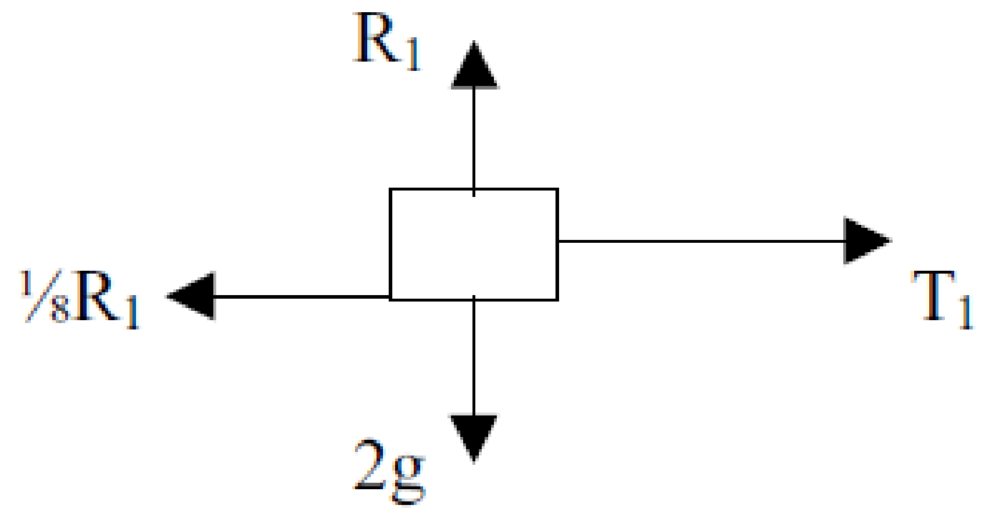

(ii) Equation of motion for each particle:
T₁ – 1/8(2g) = 2a ⇒ T₁ – g/4 = 2a
T₂ – T₁ – ¼(3g) = 3a ⇒ T₂ – T₁ – 3g/4 = 3a
5g – T₂ = 5a ⇒ 5g – T₂ = 5a

(iii)The common acceleration of the particles and the tension in each string
Neat trick – watch as we rearrange the equations as follows such that similar terms are in the same column:
T₁ – g/4 = 2a
T₂ – T₁ – 3g/4 = 3a
– T₂ 5g = 5a
Now just add all three equations: notice that the all the T terms cancel out (sometimes you might have to change all the signs in one equation for this to happen):

– g/4 – 3g/4 + 5g = 10a ⇒ a = 4 m s⁻²
Sub this value for a back into the first and third equations above to get T₁ = 10.5 N and T₂ = 30 N.

Further exam questions involving friction

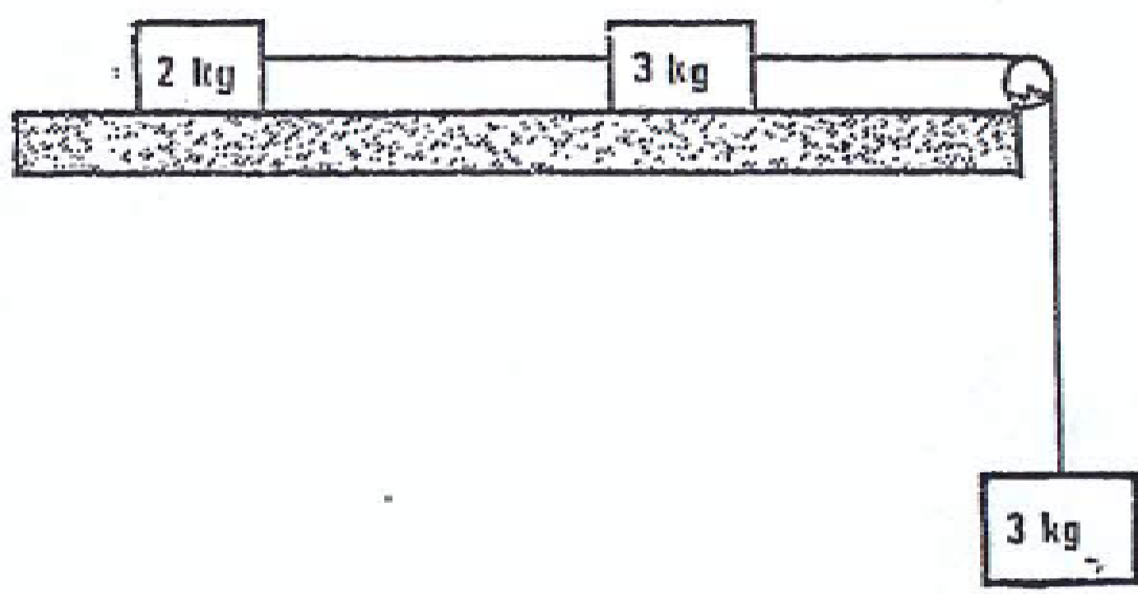
1983 (higher level!)
The diagram shows particles of mass 2 kg and 3 kg respectively lying on a horizontal table in a straight line perpendicular to the edge of the table.
They are connected by a taut, light, inextensible string.
A second such string passing over a fixed, light pulley at the edge of the table connects the 3 kg particle to another of mass 3 kg hanging freely under gravity.
The contact between the particles and the table is rough with coefficient of friction ¼.
Show in separate diagrams the forces acting on the particles when the system is released from rest.
Calculate
- the common acceleration
- the tension in each string in terms of g.

2022 (a)
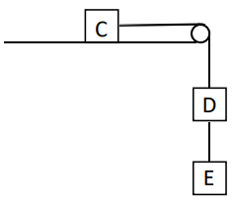
A block C of mass 6m rests on a rough horizontal table.
It is connected by a light inextensible string which passes over a smooth fixed pulley at the edge of the table to a block D of mass 3m. D is connected by another light inextensible string to a block E of mass 2m, as shown in the diagram.
The coefficient of friction between C and the table is $\frac{1}{3}$.

The system is released from rest.
- Show on separate diagrams the forces acting on each block.
- Find the acceleration of C.
- Find the tension in each string.

1998 (b) higher level {Tricky!! The trick here is to draw a free-body diagram for A and B and identify all forces acting on each – it’s not obvious - remember if B exerts a frictional force on A, then A must exert an equal and opposite force on B. Similarly there is a pair of reaction forces between A and B}
Two blocks shown in the diagram are at rest on a horizontal surface when a force P is applied to block B.

P
A
B
Blocks A and B have masses 20 kg and 35 kg respectively.
The coefficient of friction between the two blocks is 0.35 and the coefficient of friction between the horizontal surface and the block B is 0.3. Determine the maximum force P, before A slips on B.

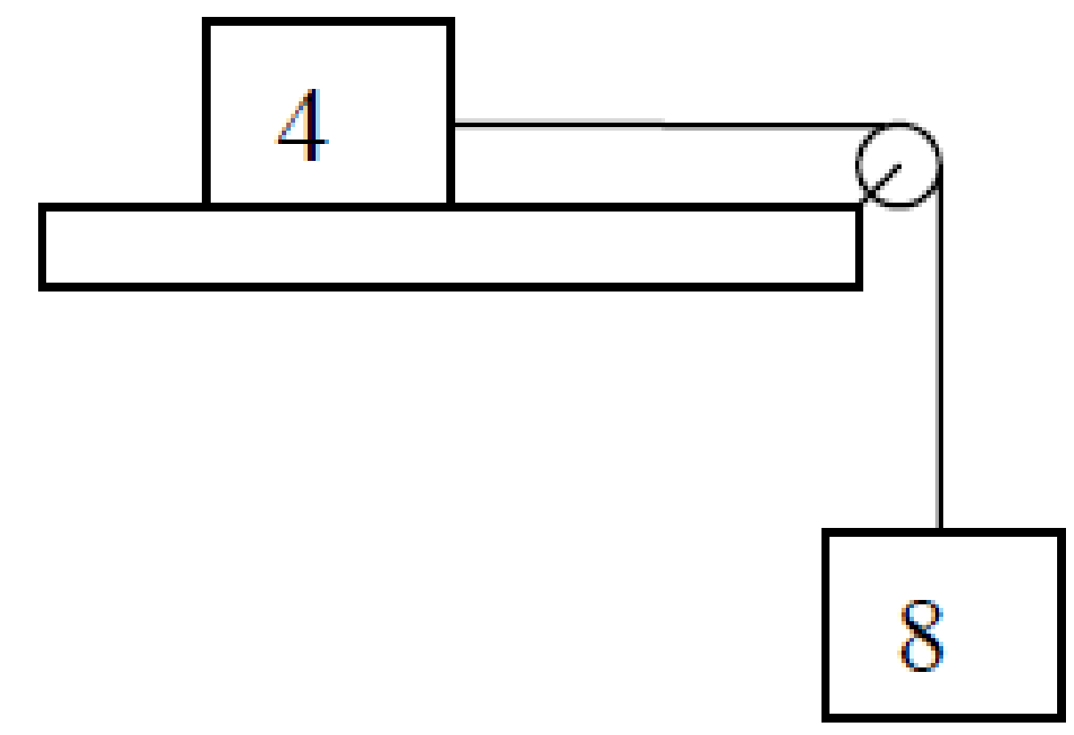
2005 (a) higher level
A particle of mass 4 kg rests on a rough horizontal table.
It is connected by a light inextensible string which passes over a smooth, light, fixed pulley at the edge of the table to a particle of mass 8 kg which hangs freely under gravity.
The coefficient of friction between the 4 kg mass and the table is 1/4.
The system starts from rest and the 8 kg mass moves vertically downwards
- Find the tension in the string
- Find the force exerted by the string on the pulley.
Part (ii) is tricky – to calculate the force on the pulley you have to use the fact that there is a tension T pulling it to the left, and an equal tension pulling it down, so the total (net) force is calculated by using Pythagoras’ theorem.

Questions involving equations of motion (vuast)
2003 (b) OL
Calculate the initial speed that a stone must be given to make it skim horizontally across ice so that it comes to rest after skimming 40 m.
The coefficient of friction between the stone and the ice is 1/8.

2006 (b) OL
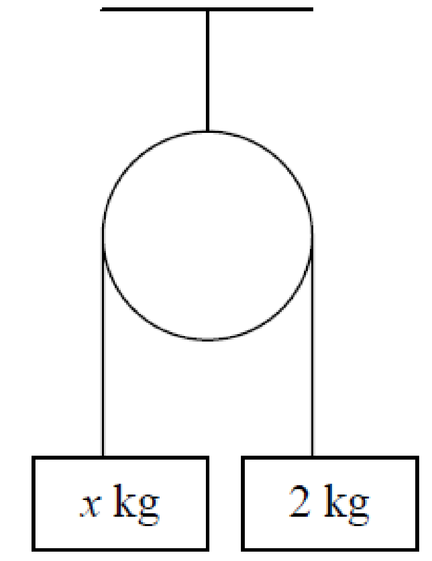
A light inelastic string passes over a smooth light pulley.
A mass of x kg is attached to one end of the string and a mass of 2 kg is attached to the other end.
When the system is released from rest the 2 kg mass falls 3 metres in √6 seconds.
Find
- the common acceleration
- the tension in the string
- the value of x.

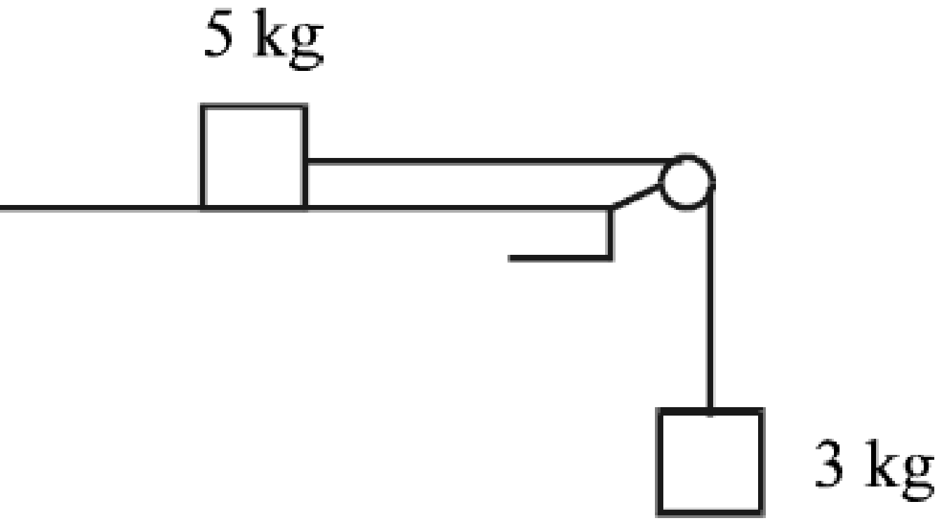
2000 (a)
A mass of 5 kg on a rough horizontal table is connected by a light inextensible string passing over a smooth light pulley, at the edge of the table, to a 3 kg mass hanging freely.
The coefficient of friction between the 5 kg mass and the table is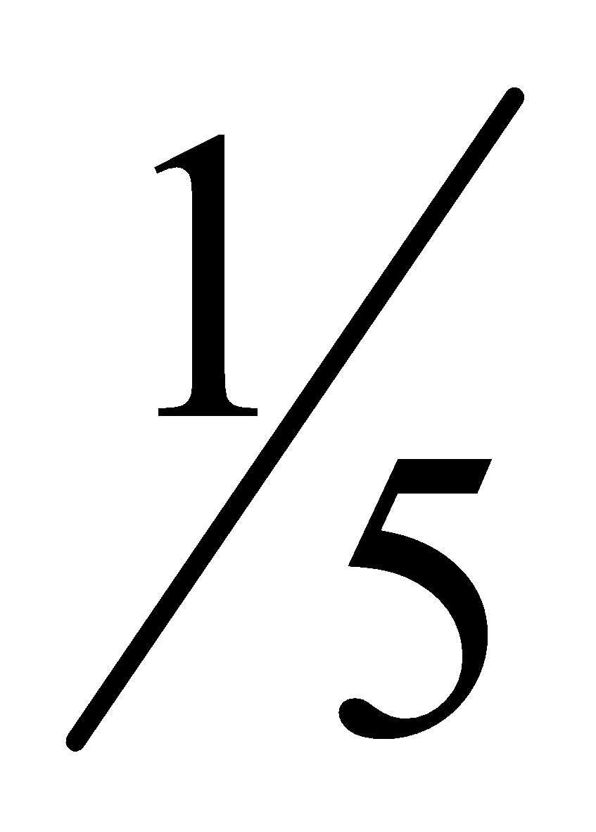.
The system is released from rest. Find the distance fallen by the 3 kg mass in the first 2 seconds after the system is released from rest.

1975
A particle of mass 4M rests on a rough horizontal table, where the coefficient of friction between the particle and the table is ¹/₃, and is attached by two inelastic strings to particles of masses 3M and M which hang over smooth light pulleys at opposite edges of the table.
The particle and the two pulleys are collinear.
Show in separate diagrams the forces acting on each of the three particles when the system is released from rest.
Find the distance fallen by the 3M particle in time t.

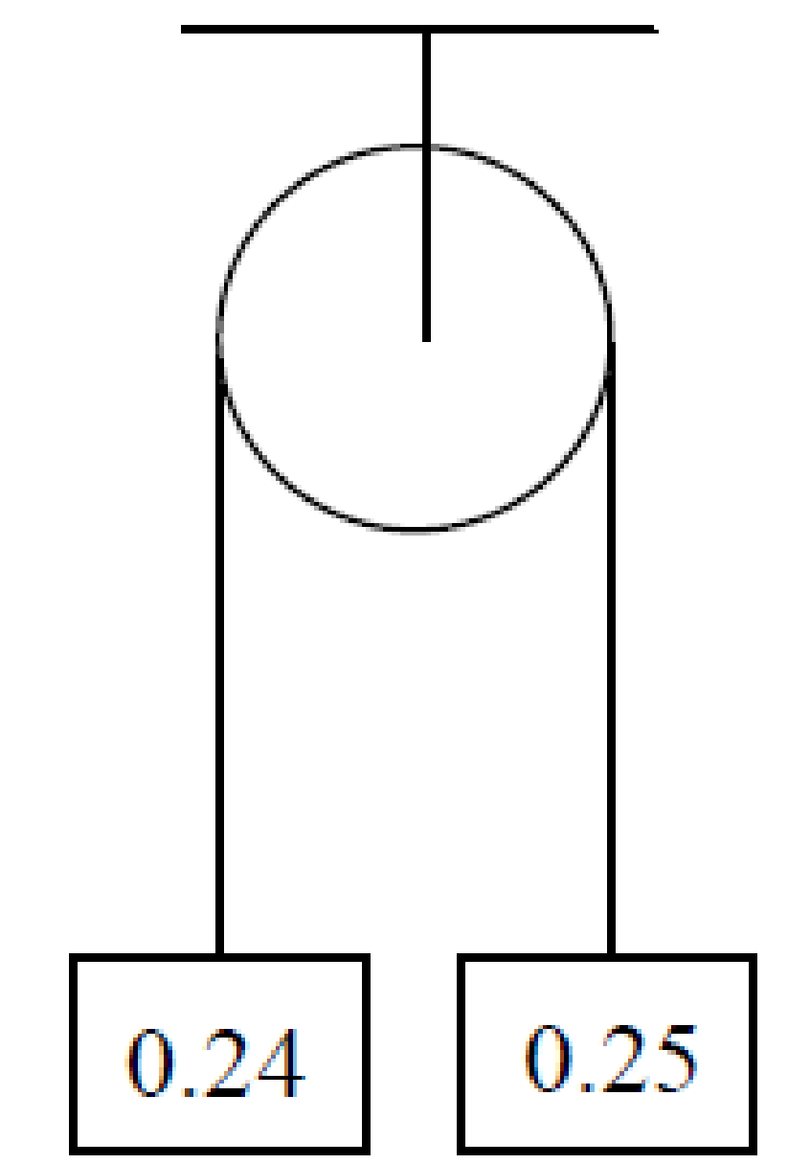
2010 (a)
Two particles of masses 0.24 kg and 0.25 kg are connected by a light inextensible string passing over a small, smooth, fixed pulley.
The system is released from rest.
Find
- the tension in the string
- the speed of the two masses when the 0.25 kg mass has descended 1.6 m.

2019 (a)
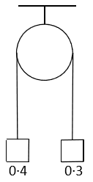
Two particles of masses 0∙4 kg and 0∙3 kg are attached to the ends of a light inextensible string which passes over a light smooth fixed pulley.
They are held at the same level, as shown in the diagram.
The system is released from rest.
Find
- the tension in the string
- the speed of the 0∙4 kg mass when it has descended 0∙7 m.

2004 (a)
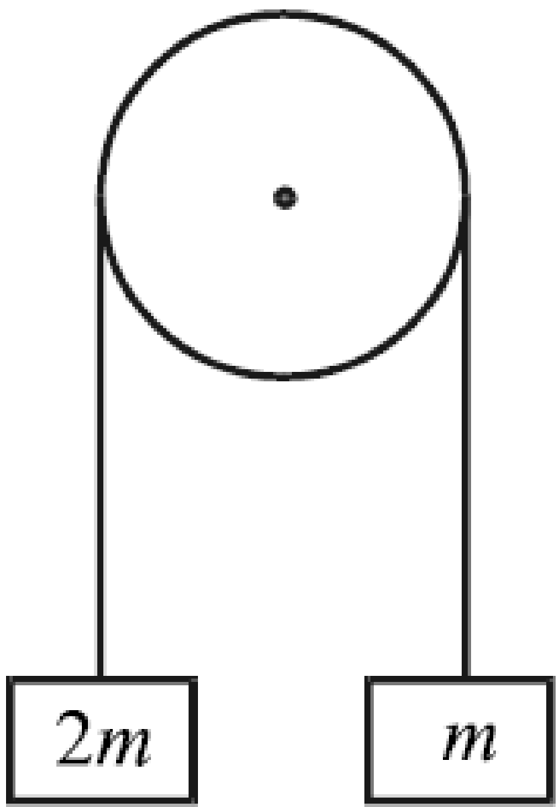
Two particles, of masses 2m and m, are attached to the ends of a light inextensible string which passes over a fixed smooth light pulley.
The system is released from rest with both particles at the same horizontal level.
- Find the acceleration of the system, in terms of g.
- The string breaks when the speed of each particle is v. Find, in terms of v, the vertical distance between the particles when the string breaks.

1997 (a)
A particle A, of mass m kg, rests on a smooth horizontal table. It is connected by a light inextensible string which passes over a light, smooth, fixed pulley to a second particle B, of mass 2 kg, which hangs freely under gravity. The system starts from rest with A at a distance of 1 metre from the pulley.
(i) Calculate the acceleration of A.
(ii) If A reaches the pulley in $\frac{5}{7}$ seconds, find m.

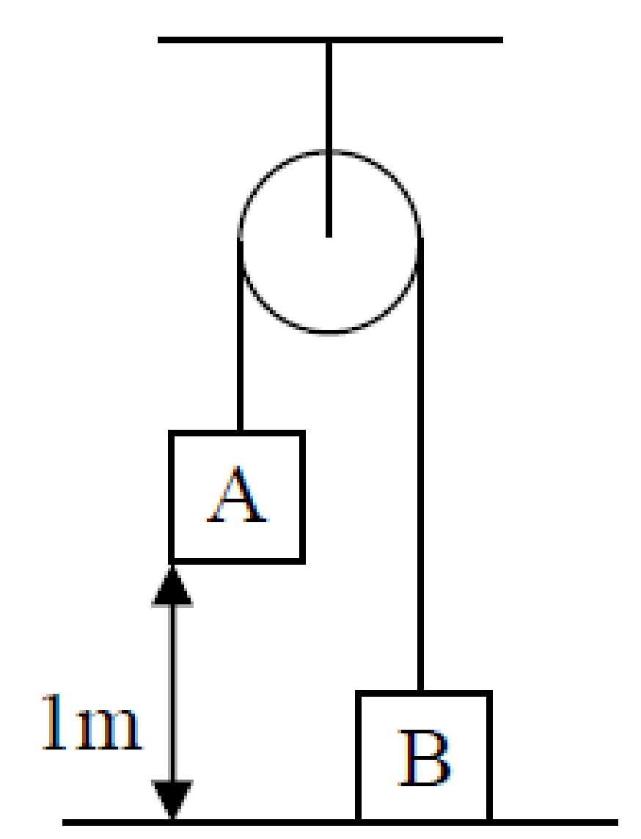
2009 (a)
A light inextensible string passes over a small fixed smooth pulley.
A particle A of mass 10 kg is attached to one end of the string and a particle B of mass 5 kg is attached to the other end.
The system is released from rest when B touches the ground and A is 1 m above the ground.
- Find the speed of A as it hits the ground
- Find the height that B rises above the horizontal ground.

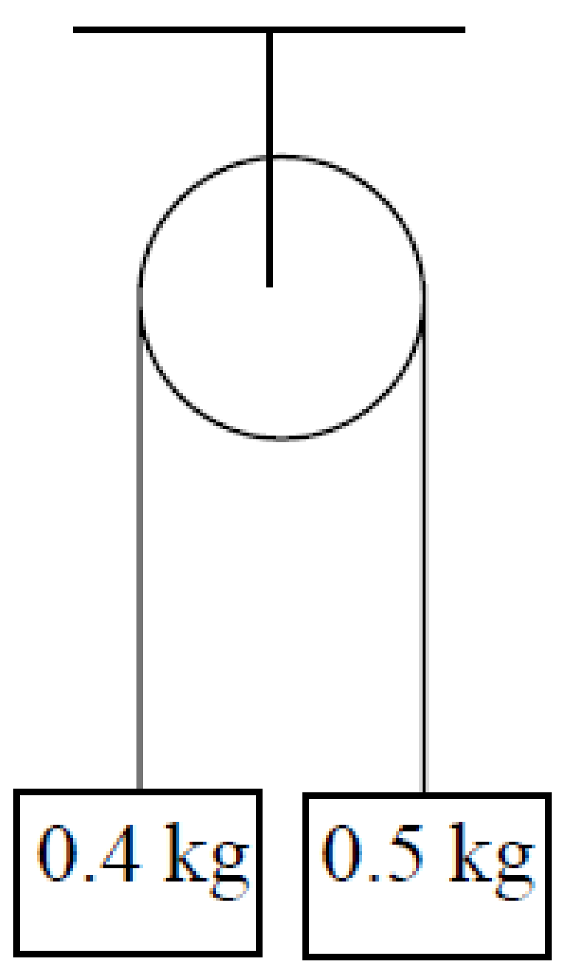
2006 (a)
Two particles of mass 0.4 kg and 0.5 kg are attached to the ends of a light inextensible string which passes over a fixed smooth light pulley.
The system is released from rest.
- Find the acceleration of the system, in terms of g.
- After falling 1 m the 0.5 kg mass strikes a horizontal surface and is brought to rest. The string again becomes taut after t seconds.
Find the value of t correct to two places of decimals

Questions involving conservation of momentum

For the following questions you need to invoke conservation of momentum to calculate the common velocity of the masses

1995
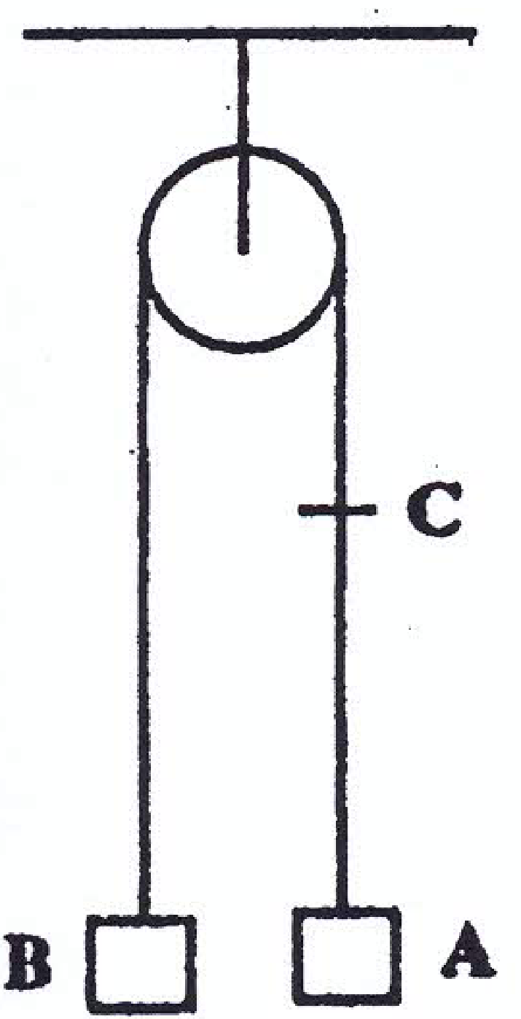
Two particles A and B of mass 0.4 kg and 0.5 kg respectively are connected by a light inextensible string which passes over a smooth pulley.
When A has risen for 1 second, it passes a point C and picks up a mass of 0.2 kg.
Find
- the initial acceleration
- the velocity of A just before it picks up the mass C.
- using the principle of conservation of momentum, or otherwise, the velocity of A after picking up the mass C.
- the distance of A from C at the first position of instantaneous rest.

2005 (b)
Two particles of masses 3 kg and 5 kg are connected by a light inextensible string, of length 4 m, passing over a light smooth peg of negligible radius.
The 5 kg mass rests on a smooth horizontal table.
The peg is 2.5 m directly above the 5 kg mass. The 3 kg mass is held next to the peg and is allowed to fall vertically a distance 1.5 m before the string becomes taut.
- Show that when the string becomes taut the speed of each particle is $\frac{3(3g)}{8}$ 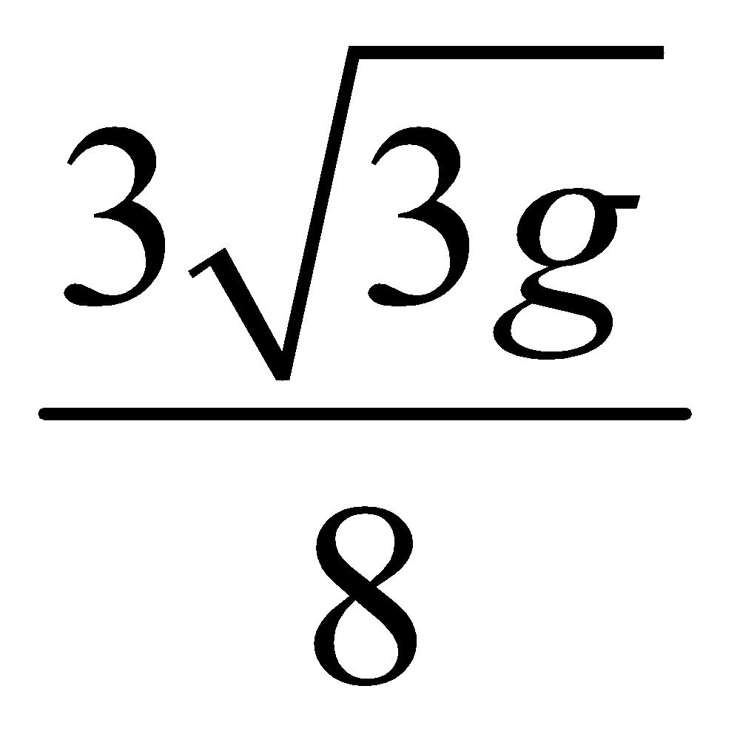m/s.
- Show that the 3 kg mass will not reach the table.

2015 (a)
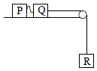
Two particles P and Q, of mass 4 kg and 7 kg respectively, are lying 0.5 m apart on a smooth horizontal table.
They are connected by a string 3.5 m long. Q is 6 m from the edge of the table and is connected to a particle R, which is of mass 3 kg and is hanging freely, by a taut light inextensible string passing over a light smooth pulley.
The system is released from rest.
Find
- the initial acceleration of Q and R
- the speed of Q when it has moved 3 m
- the speed with which P begins to move.

Movable Pulleys

- Same string ⇒ Same tension
- Different strings ⇒ different tensions
- Light pulley ⇒ no mass ⇒ right hand side of F = ma equation is 0
- A fixed pulley is external to the system so don’t consider it when getting equations of motion.
- Watch out for questions where the acceleration on one side is twice the acceleration on the other (tip: use a and 2a rather than a/2 and a).
- If you don’t know which way the system is accelerating don’t worry – just guess, and then be consistent for each object. If you guessed wrong your answer will just turn out to be minus. You will still get full marks, although you should recognise the significance of the minus.

We need to have two equations with only a and b in them.
We do this as follows
- Arrange all four equations together, with similar variables over each other.
- Add the two longest equations (the two S’s cancel out) to get the first of our two equations.
- We get the second equation by adding together all four initial equations. We may have to change the sign in one equation to allow all the S’s and T’s to cancel.
- Solve these two simultaneous equations

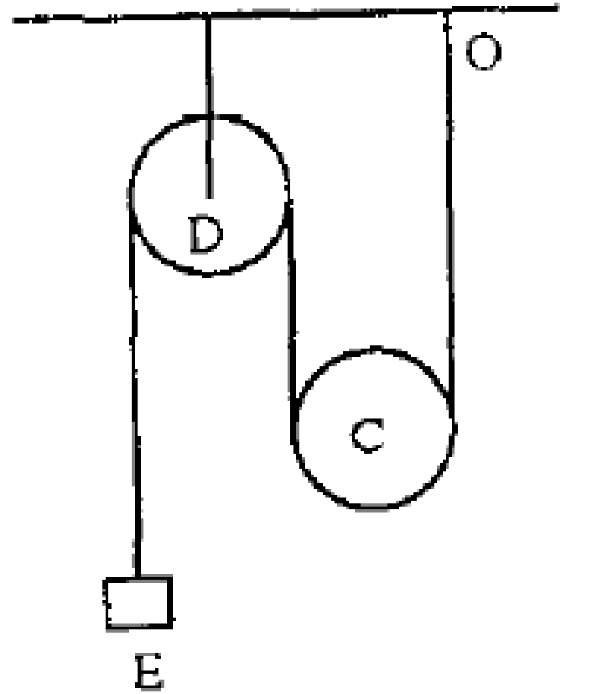
1997 (b)
The diagram shows a light inextensible string having one end fixed at O, passing under a smooth movable pulley C of mass km kg and then over a fixed smooth light pulley D. The other end of the string is attached to a particle E of mass m kg.
- Show on separate diagrams the forces acting on each mass when the system is released from rest.
- Show that the upward acceleration of C is 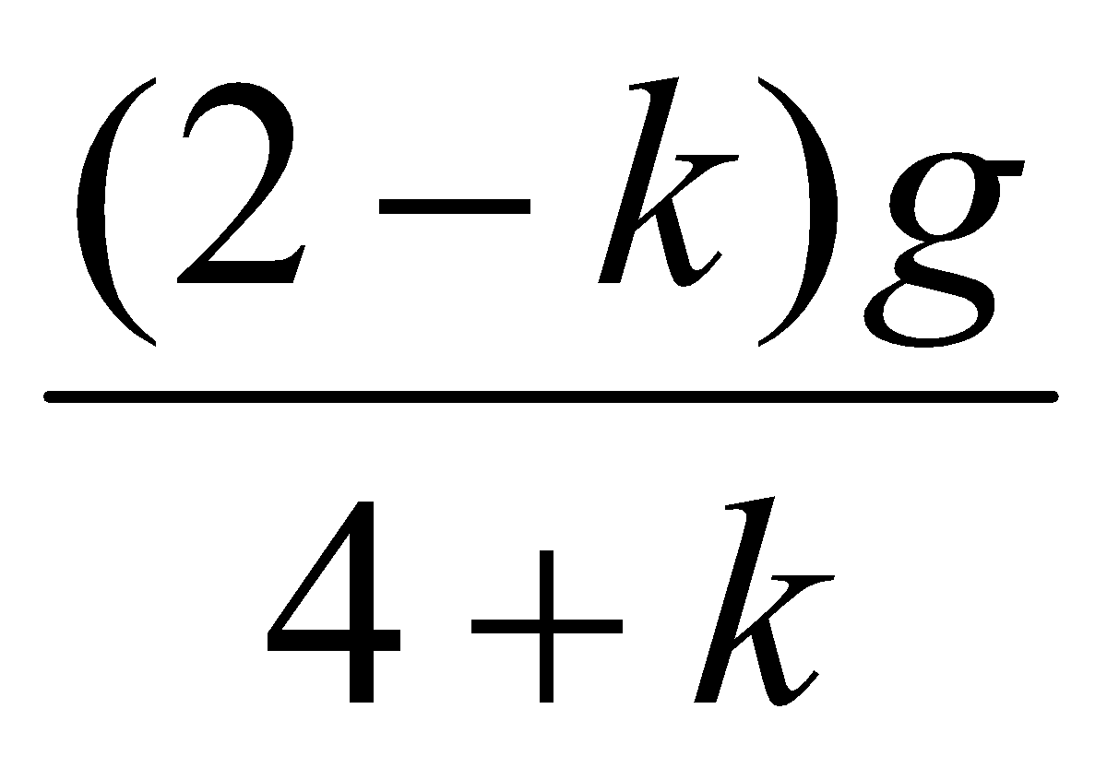.
- If k = 0.5, find the tension in the string.

Look at what happens here – as particle C moves upwards (say) then for every metre it rises it will ‘give’ 2 metres of rope to particle E, so if C has an acceleration of a, then E will have an acceleration of 2a.
Here’s a challenge for you – how would you show that acceleration is proportional to the distance travelled in this scenario?
This analysis would also apply if we assume that C drops and E rises. Therefore the respective equations of motion are as follows:
E: mg – T = m(2a)
C: 2T – kmg = kma
Solve to get the required value for a.

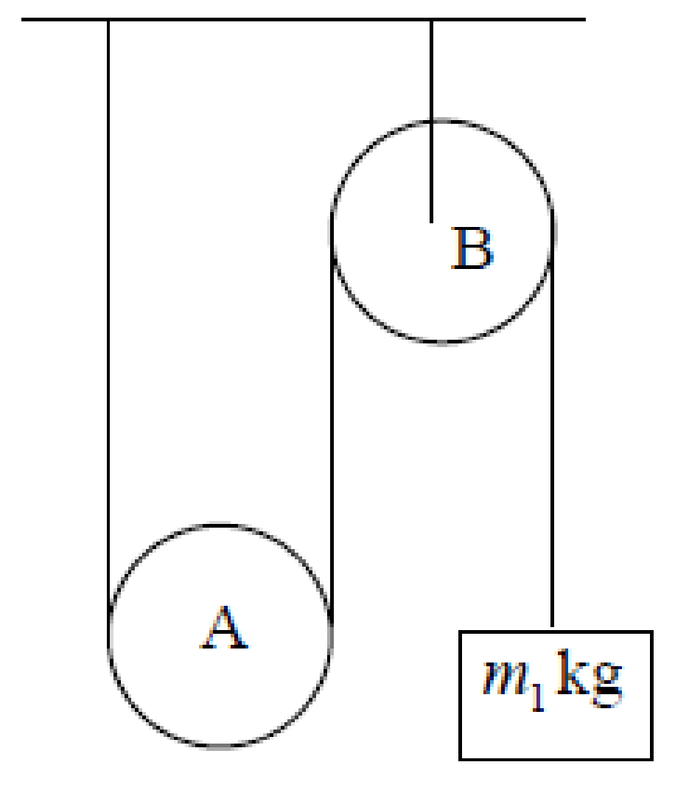
2008 (a)
The diagram shows a light inextensible string having one end fixed, passing under a smooth movable pulley A of mass m kg and then over a fixed smooth light pulley B.
The other end of the string is attached to a particle of mass m₁ kg.
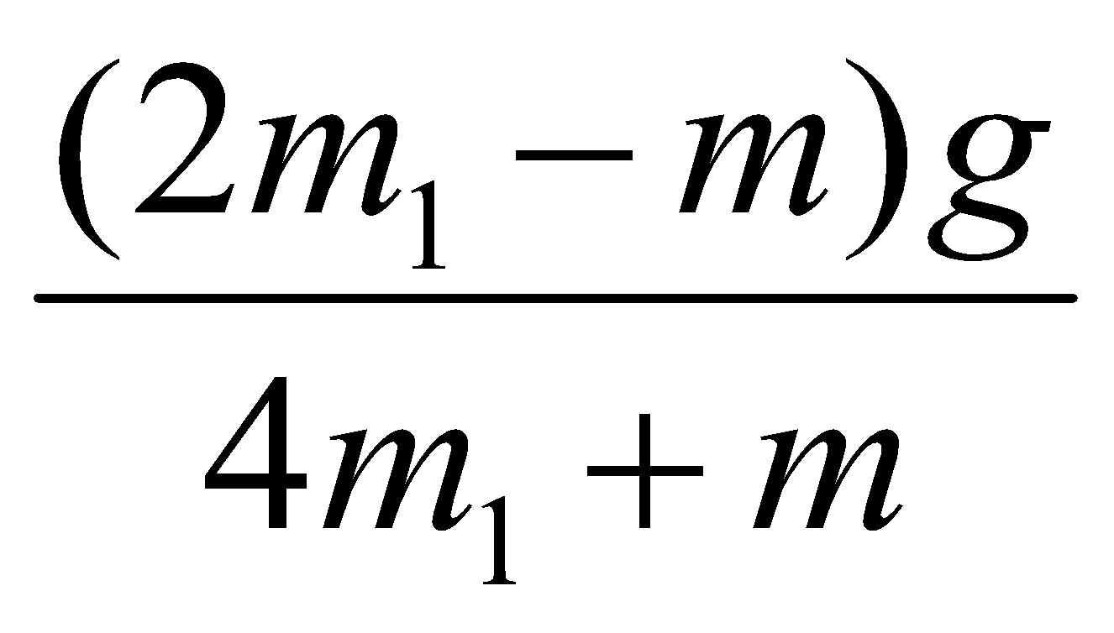
The system is released from rest.
Show that the upward acceleration of A is

2021 Question 4 (a)
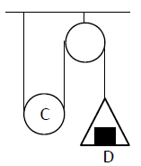
The diagram shows a light inextensible string having one end fixed, passing under a smooth movable pulley C of mass km kg and then over a fixed smooth pulley.
The other end of the string is attached to a light scale pan.
A bock D of mass m kg is placed symmetrically on the centre of the scale pan.
The system is released from rest. The scale pan moves upwards.
- Show that k > 2.
- Find, in terms of k and m, the tension in the string.
- Find, in terms of k and m, the reaction between D and the scale pan.

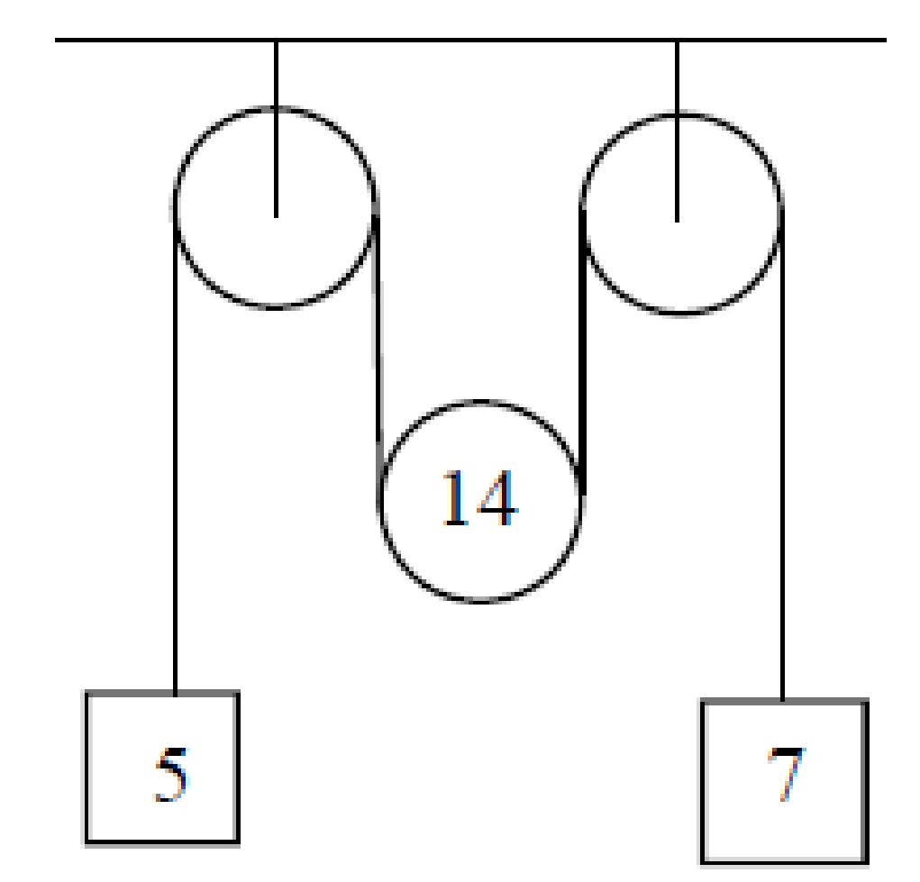
2016 (b)
A light inextensible string passes over a small smooth fixed pulley, under a small smooth moveable pulley, of mass 14 kg, and then over a second small smooth fixed pulley.
A 5 kg mass is attached to one end of the string and a 7 kg mass is attached to the other end.
The system is released from rest.
- Find the tension in the string.
- If instead of the system starting from rest, the moveable pulley is given an initial upward velocity of 0·8 m s^{–1}, find the time taken until the moveable pulley reverses direction.

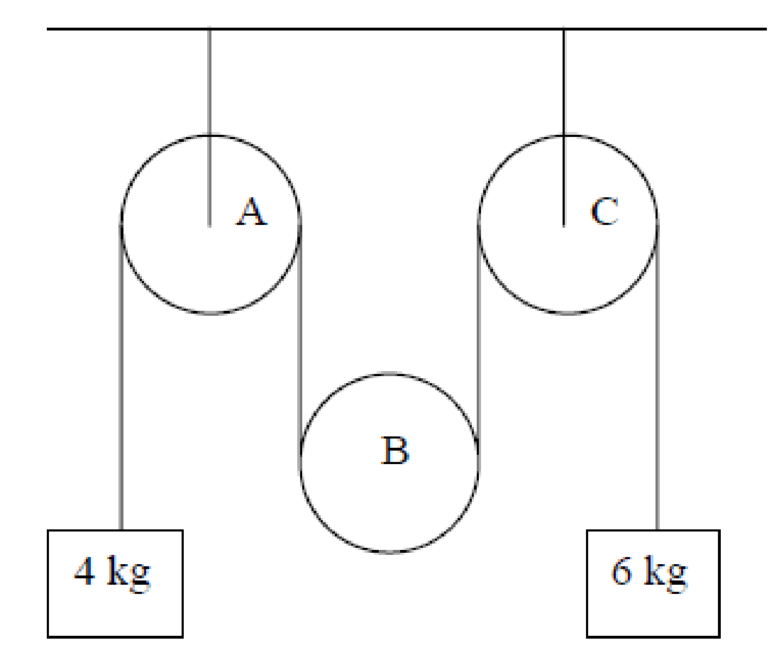
2007 (b)
A light inextensible string passes over a small fixed pulley A, under a small moveable pulley B, of mass m kg, and then over a second small fixed pulley C.
A particle of mass 4 kg is attached to one end of the string and a particle of mass 6 kg is attached to the other end.
The system is released from rest.

- On separate diagrams show the forces acting on each particle and on the moveable pulley B.
- Find, in terms of m, the tension in the string.
- If m = 9.6 kg prove that pulley B will remain at rest while the two particles are in motion.

2018 (b)
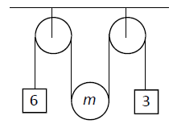
A moveable pulley of mass m is suspended on a light inextensible string between two fixed pulleys as shown in the diagram.
Masses of 6 kg and 3 kg are attached to the ends of the string.
The system is released from rest.
- Show, on separate diagrams, the forces acting on the moveable pulley and on each of the masses.
- Find in terms of m the tension in the string.
- For what value of m will the acceleration of the moveable pulley be zero?

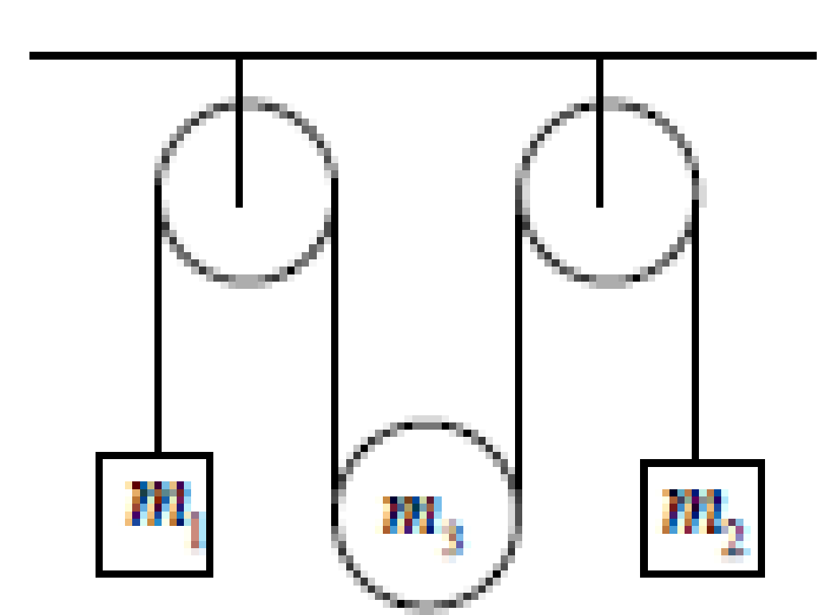
2013 (b)
A light inextensible string passes over a smooth fixed pulley, under a movable smooth pulley of mass m₃, and then over a second smooth fixed pulley.
A particle of mass m₁ is attached to one end of the string and a particle of mass m₂ is attached to the other end.
The system is released from rest.
Find the tension in the string in terms of m₁, m₂, and m₃.

1992
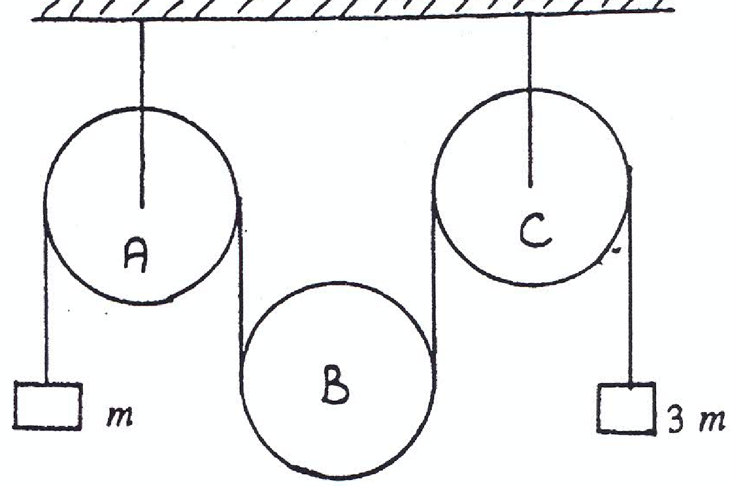
A light inextensible string passes over a movable pulley B of mass M and then over a second fixed pulley C.
A mass m is attached to one end of the string and a mass 3m is attached to the other end.
If the system is released from rest
- Show in a diagram the forces acting on each of the three masses.
- Prove that the tension, T, of the string is given by the equation 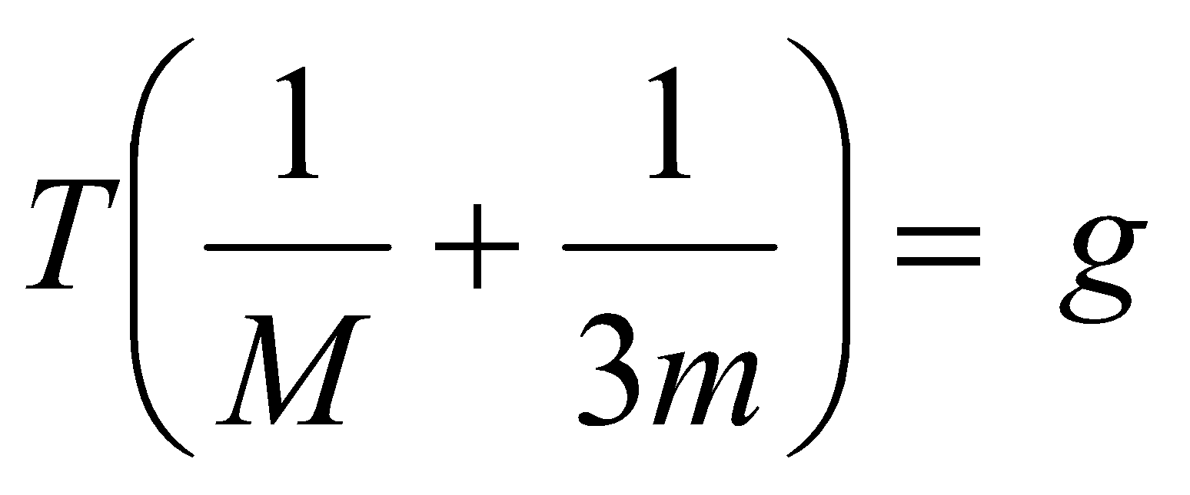
- Show that if M = 3m then the pulley B will remain at rest while the two masses are in motion.

2022 Deferred (a)
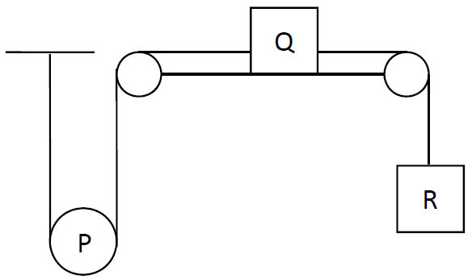
A taut light inelastic string is fixed at one end and passes under a moveable pulley, P, of mass 4 kg which hangs vertically. The other end of the string is attached to Q, a mass of 4 kg which lies on a rough horizontal surface.
A second inelastic string connects Q to R, a mass of 10 kg which hangs vertically.
The fixed pulleys are smooth and light and the coefficient of friction between Q and the surface is ½.
The system is released from rest.
Find the accelerations of P, Q and R in terms of g.

2009 (b)
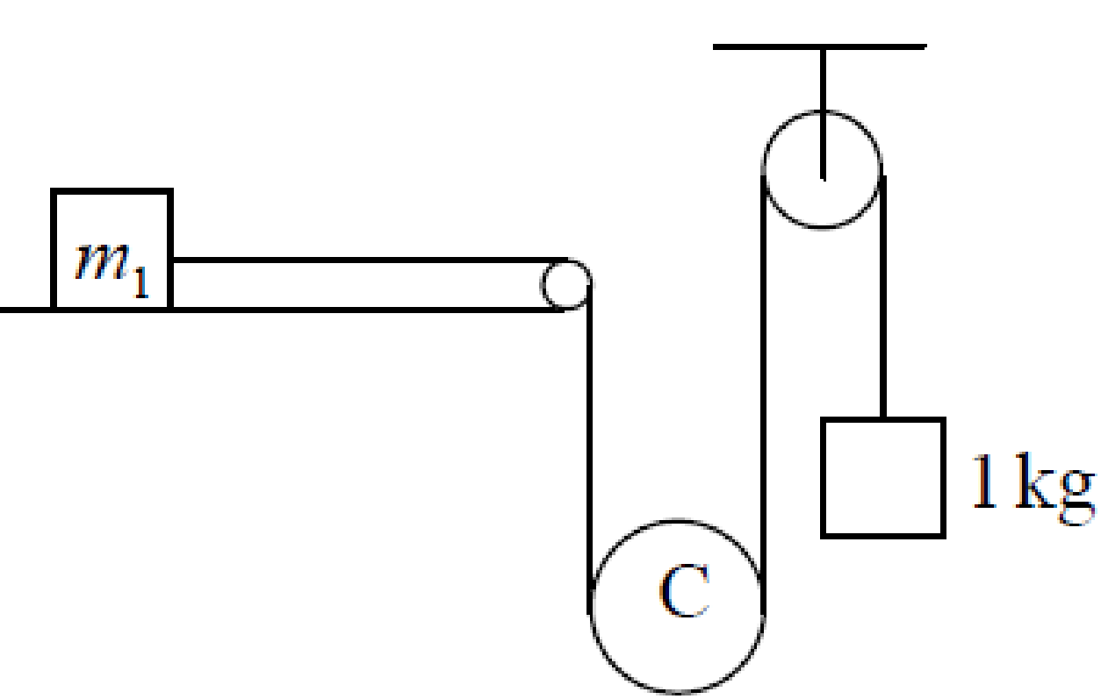
A mass m₁ kg is at rest on a smooth horizontal table. It is attached to a light inextensible string.
The string, after passing over a small fixed pulley at the edge of the table, passes under a small moveable pulley C, of mass m₂ kg.
The string then passes over a smooth fixed pulley and supports a mass of 1 kg.
The system is released from rest.
- Find, in terms of m₁ and m₂ , the tension in the string.
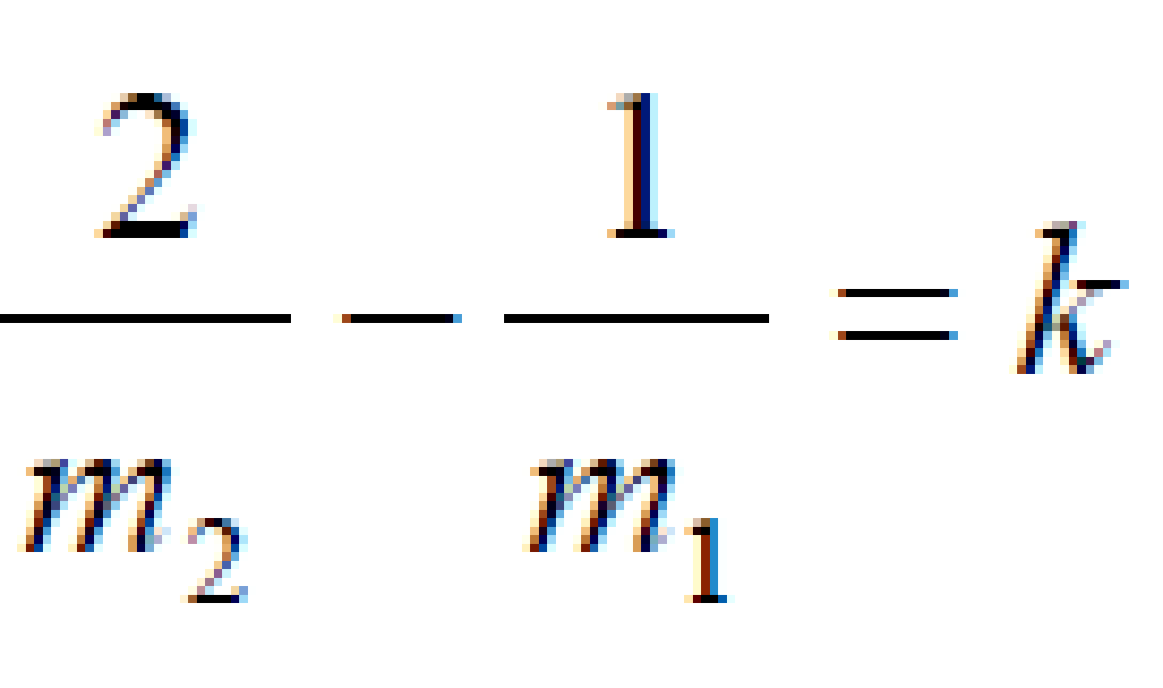
- The pulley C will remain at rest if
Find the value of k.

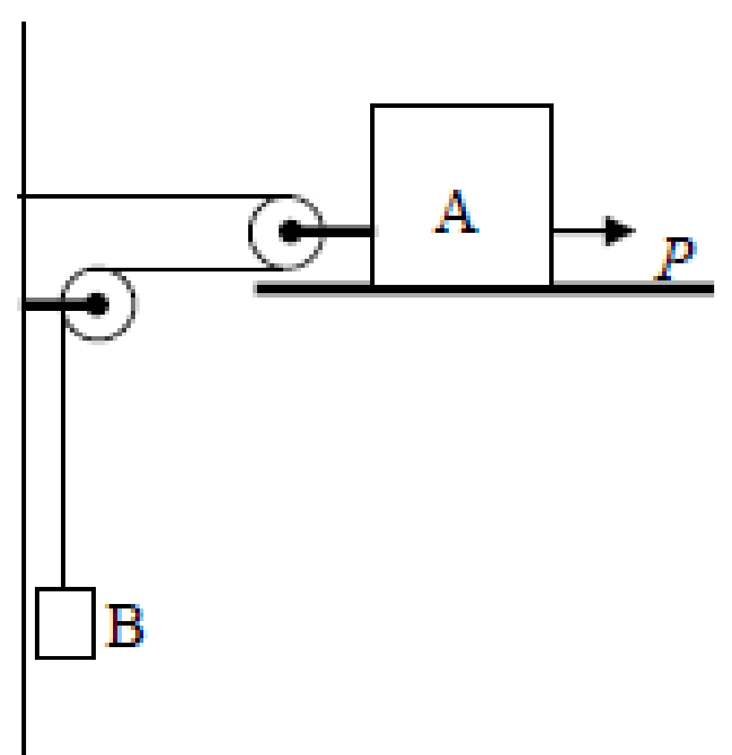
2014 (a)
A block A of mass 4 kg, can slide on a rough horizontal table.
It is connected inelastically to a pulley system from which B, a mass of 8 kg, hangs freely under gravity by a light inelastic string, as shown in the diagram.
A horizontal force P of 320 N is applied to the mass A, which then moves in the direction of P.
The coefficient of friction between A and the table is $\frac{4}{7}$.

Find
- the acceleration of A
- the tension in the string connected to B.

1990
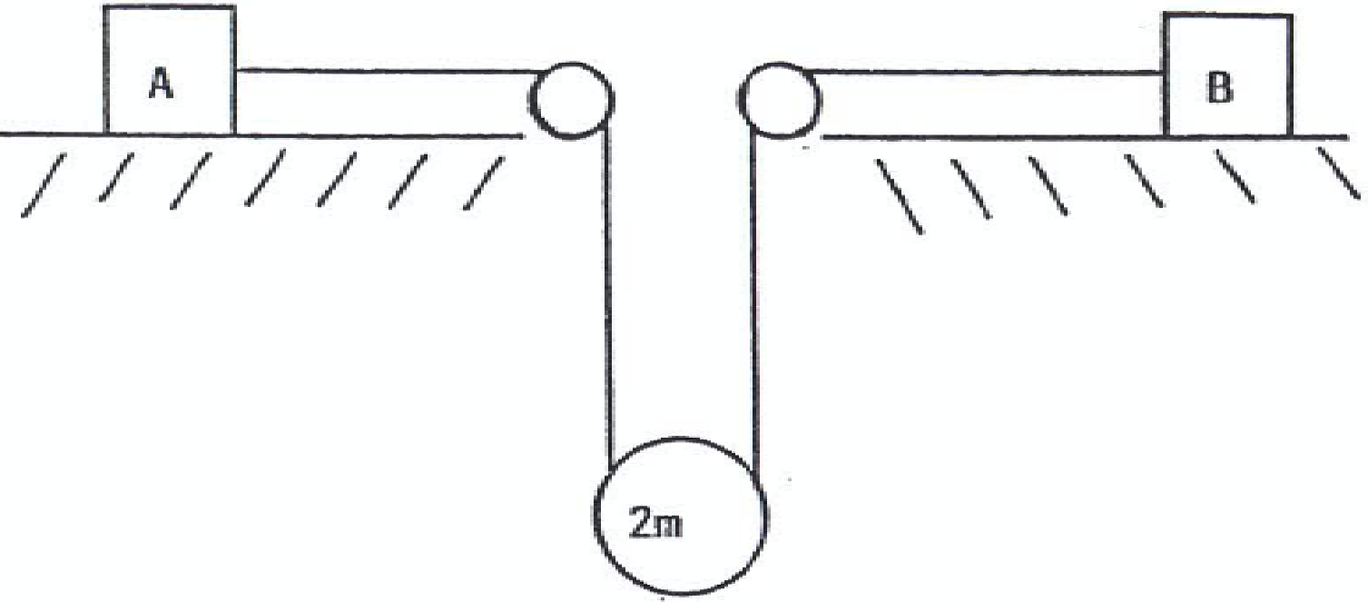
Two blocks A and B each of mass m kg, lie at rest on horizontal rough tables.
The coefficient of friction between A and the table is μ, and between B and its table is ¼.
The blocks are connected by a light inextensible string which passes under a smooth movable pulley of mass 2m kg.

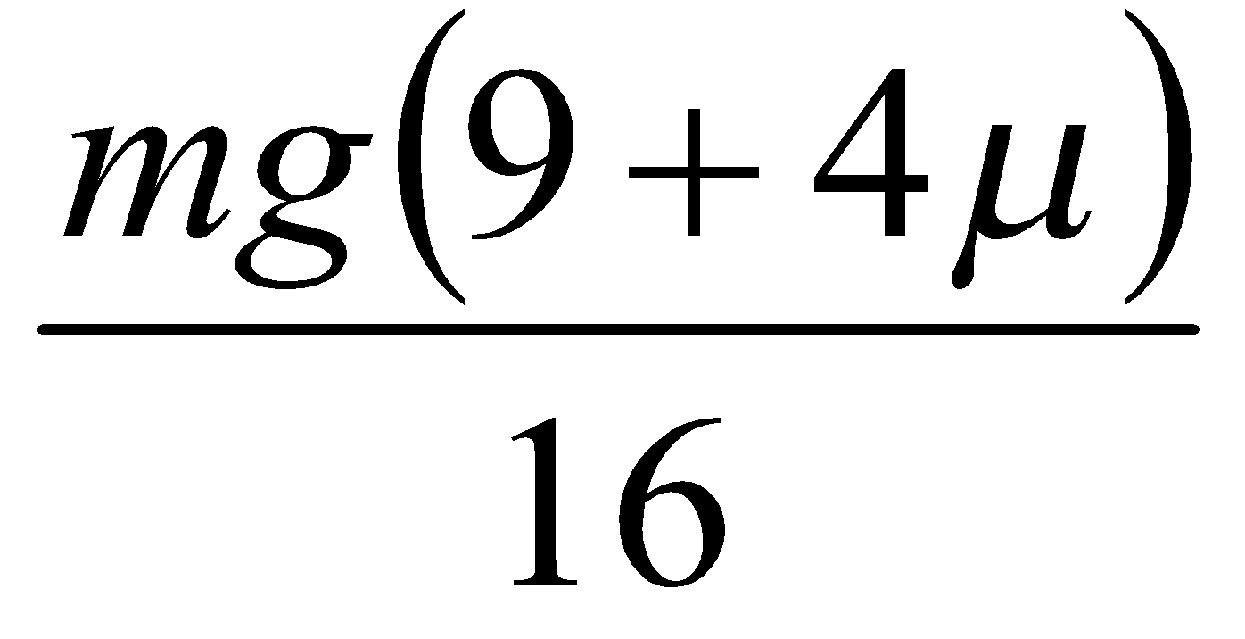
- Show in a diagram the forces on each mass when the system is released from rest.
- If μ < ¾, prove that the tension in the string is
- Prove that A will not move if μ > ¾.

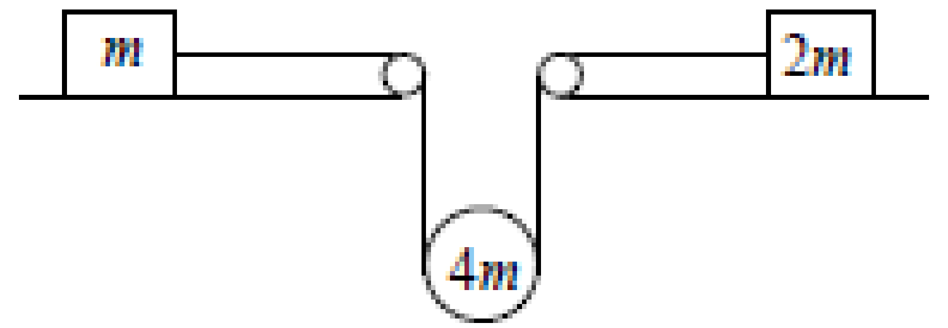
2012 (b)
Two particles of mass m kg and 2m kg lie at rest on horizontal rough tables.
The coefficient of friction between each particle and the table it lies on is μ (μ<$\frac{2}{3}$)

The particles are connected by a light inextensible string which passes under a smooth movable pulley of mass 4m kg.
The system is released from rest.
- Find, in terms of m and μ, the tension in the string.
If the acceleration of the m kg mass is f, find the acceleration of the 2m kg mass in terms of f.

1988
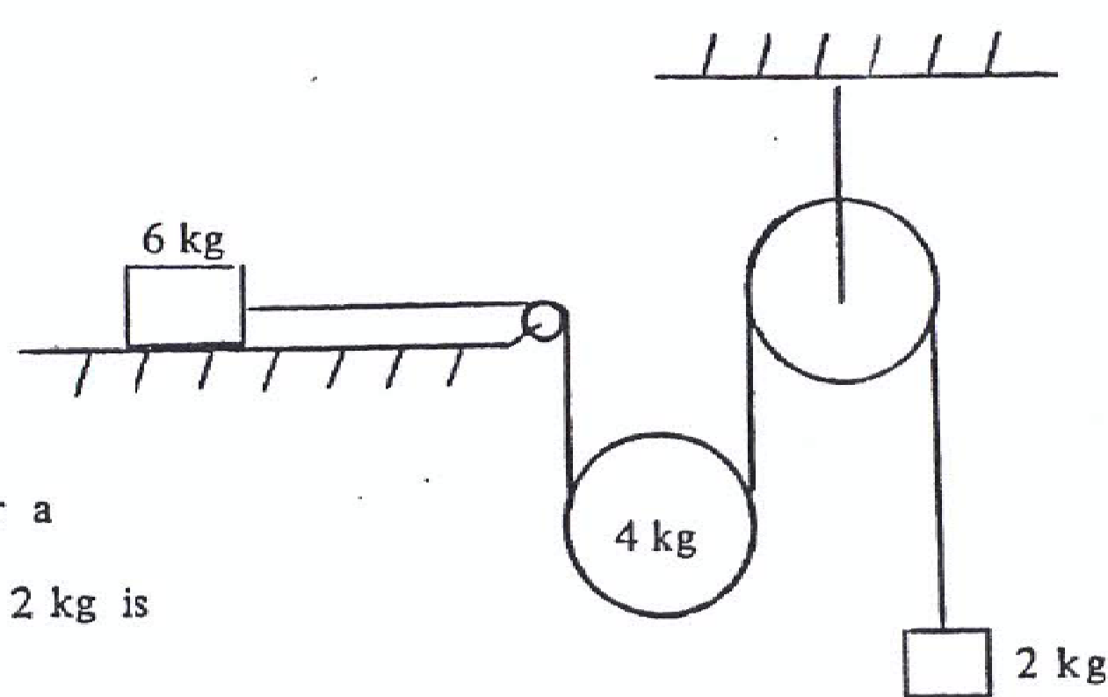
One end of a light inextensible string is attached to a mass of 6 kg which rests on a rough horizontal table.
The coefficient of friction between the mass and the table is.
The string passes over a smooth fixed pulley at the edge.
Then it passes under a smooth movable pulley of mass 4 kg and over a smooth fixed pulley.
A mass of 2 kg is attached to its other end.

- Show on separate diagrams the forces acting on each mass.
- Calculate the acceleration of each mass and the tension in the string in terms of g, the acceleration due to gravity.

Source: xkcd.com

Wedges

Ordinary Level

These look quite different, but in reality there is only one extra complicating term.
We have already seen from Projectiles that we can resolve a velocity into two perpendicular components (which we called Ux and Uy).
Similarly for these questions, if we consider the surface of the wedge to be our X-axis then we need to resolve the gravitational and reaction forces into directions parallel to and perpendicular to this axis.

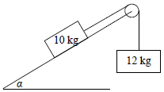
Worked example: 2015 (b) OL
Masses of 10 kg and 12 kg are connected by a taut light inelastic string which passes over a light smooth pulley, as shown in the diagram.
The 10 kg mass lies on a smooth plane inclined at α to the horizontal, where tan α = $\frac{4}{3}$.
The 12 kg mass hangs vertically.

The system is released from rest.
Find
- the common acceleration of the particles
- the tension in the string.

Solution
For the 12 kg mass we do the same as we have always done:
12g – T = 12a - - - - - - - - - - - - - - - - - - - - - - - - - - - - - - - - - - equation 1

For the 10 kg mass we use the slope of the plane as our X-axis.
This means we need to find the component of gravity acting parallel to the surface of the plane.
We can see from the diagram that this is 10g sin α.

The only other force acting on the 10 kg mass in the X-direction is the tension T, so the equation of motion becomes
T - 10g sinα = 10a

We also know that rather than using a calculator to find α we should instead make out a 3, 4, 5 triangle and we quickly see that sin α = 4/5

So we get T – 10g (4/5) = 10a which simplifies to
T – 8g = 10a - - - - - - - - - - - - - - - - - - - - - - - - - - - - - - - - - equation 2

We now solve equation 1 and equation 2 as before to get

a =
T =

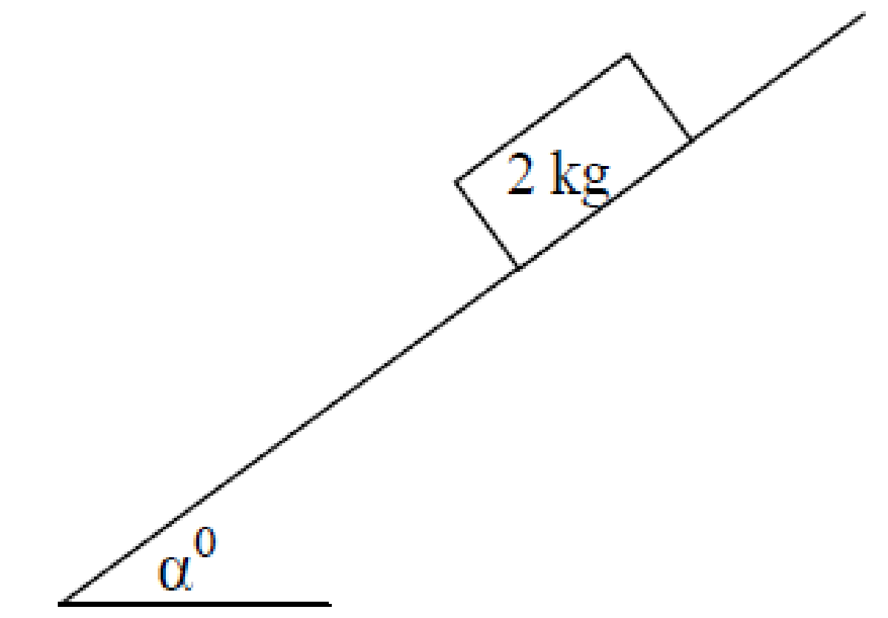
Worked example: 2009 (b) OL
A particle of mass 2 kg is released from rest and slides down a rough plane which is inclined at an angle α⁰ to the horizontal, where tan α = 4/3.
The coefficient of friction between the particle and the plane is ½ .
- Show on a diagram the forces acting on the particle.
- Find the acceleration of the particle.

Solution
First we make out a new diagram showing all the forces acting on the 2 kg mass.
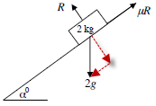

The difference between this question and the last is that here we have a friction force (but no tension).

Using Force_{big} – Force_{small} = ma we get
2g sinα - Friction force = 2a
2g sinα - µR = 2a - - - - - - - - - - equation 1

In this case we can see that the 2 kg particle is nether jumping off the plane or sinking in to it, so the force upwards perpendicular to the plane (R) must equal the force in the opposite direction (2g cos α).
→ R = 2g cosα

Equation 1 now becomes: 2g sinα - µ{2g cosα} = 2a

We also know that rather than using a calculator to find α we should instead make out a 3, 4, 5 triangle and we quickly see that cosα = 3/5 and sinα = 4/5

We also know that µ = ½ and that at ordinary level g = 10,
So the equation now becomes: (2)(10)(4/5) – (1/2)(2)(10)(3/5) = 2a

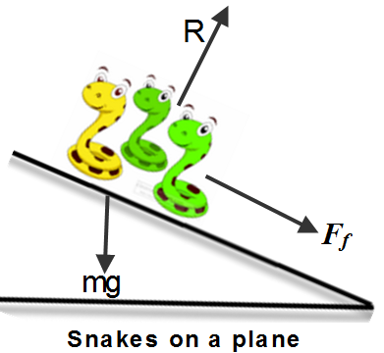
Solve to get a = 5 m s⁻²

Ordinary level exam questions

2007 (b) OL {The forces are tension, reaction force, gravity and friction}
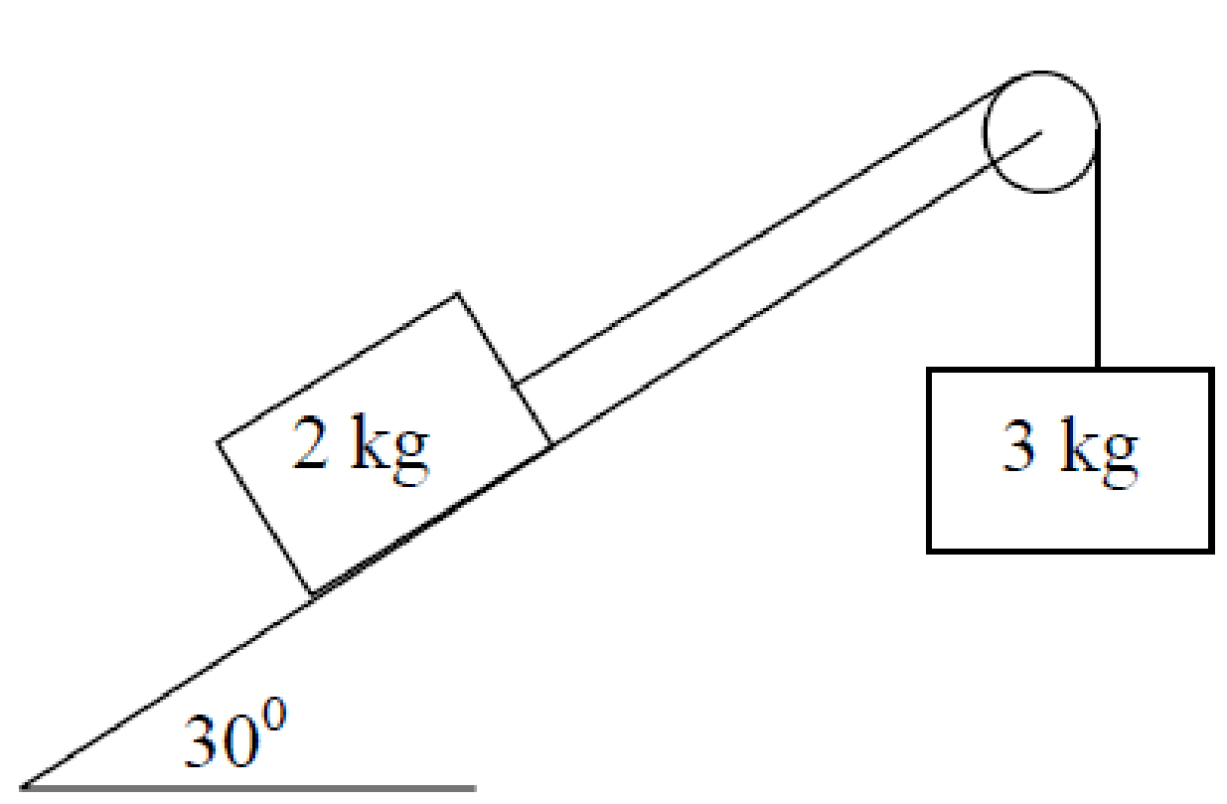
A rough plane is inclined at 30⁰ to the horizontal and has a smooth light pulley attached to its uppermost point.
A taut, light, inelastic string passes over the pulley and has masses of 3 kg and 2 kg attached to its end points.
The coefficient of friction between the 2 kg mass and the plane is $\frac{1}{\sqrt{3}}$.
The 3 kg mass hangs vertically.
The system is released from rest.
The 3kg mass moves vertically downwards.
- Show on separate diagrams all the forces acting on each mass.
- Find the common acceleration.
- Find the tension in the string.

2014 (b) OL
Masses of 6 kg and 10 kg are connected by a taut, light, inextensible string which passes over a smooth light fixed pulley as shown in the diagram.
The 6 kg mass lies on a rough horizontal plane and the coefficient of friction between the 6 kg mass and the plane is $\frac{2}{3}$.
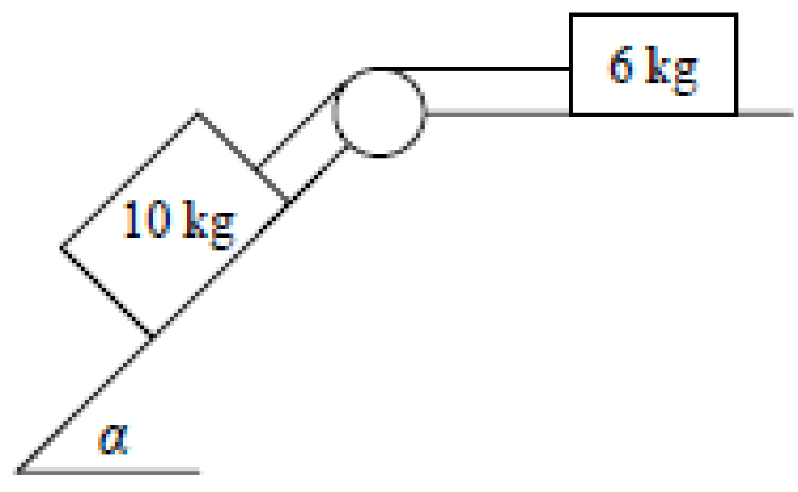
The 10 kg mass lies on a smooth plane which is inclined at an angle α to the horizontal, where tan α = $\frac{4}{3}$.

The system is released from rest.
- Show on separate diagrams the forces acting on each particle.
- Find the common acceleration of the masses.
- Find the tension in the string.

2016 (b) OL
Masses of 8 kg and 12 kg are connected by a taut, light, inextensible string which passes over a smooth light fixed pulley as shown in the diagram.
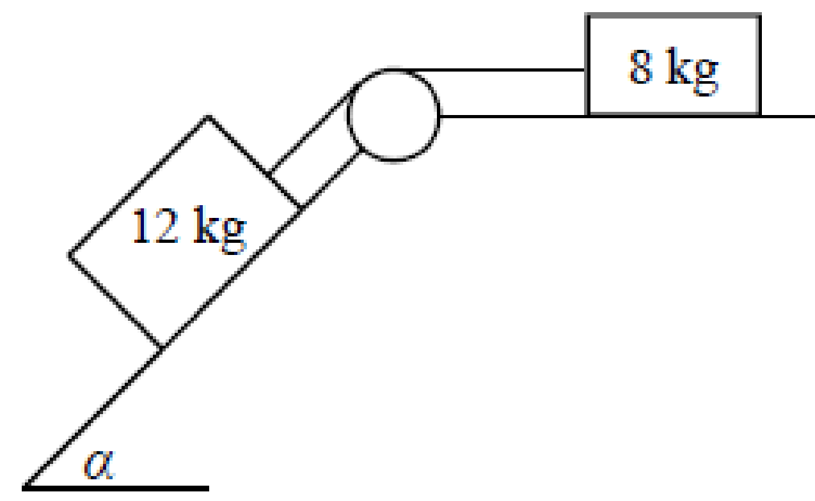
The 8 kg mass lies on a rough horizontal plane and the coefficient of friction between the 8 kg mass and the plane is $\frac{3}{4}$.
The 12 kg mass lies on a smooth plane which is inclined at an angle α to the horizontal, where tan α = $\frac{4}{3}$.
The system is released from rest.
(i) Show on separate diagrams the forces acting on each mass.
(ii) Find the common acceleration of the masses.
(iii) Find the tension in the string.
(iv) Find the common speed of the masses after two seconds of motion.

2008 (b) OL
Masses of 3 kg and 6 kg are connected by a taut, light, inextensible string which passes over a smooth light pulley as shown in the diagram.
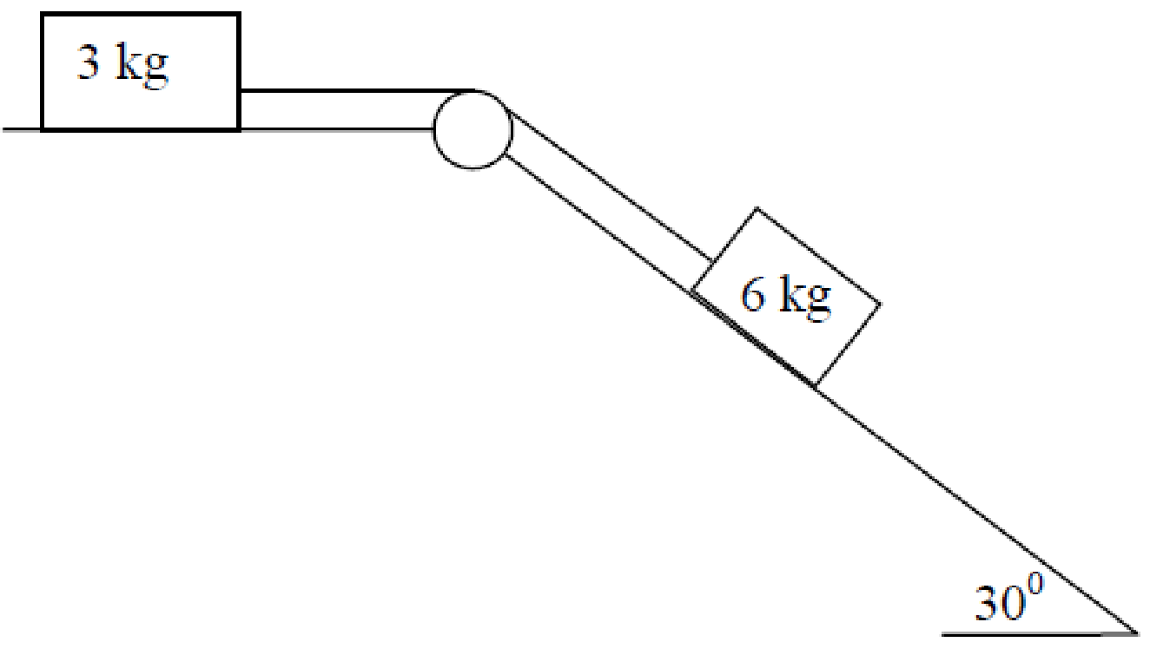
The 3 kg mass lies on a rough horizontal plane and the coefficient of friction between the 3 kg mass and the plane is μ.
The 6 kg mass lies on a smooth plane which is inclined at 30⁰ to the horizontal.
When the system is released from rest each mass travels 1 metre in √2 seconds.
Find
- the common acceleration of the masses
- the tension in the string
- the value of μ.

2017 (b) OL
Masses of 5 kg and 3 kg are connected by a taut light inelastic string which passes over a light smooth pulley, as shown in the diagram.
The 5 kg mass lies on a smooth plane inclined at α° to the horizontal, where tan α = $\frac{4}{3}$.
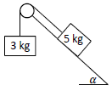
The 3 kg mass hangs vertically.
The system is released from rest.
Find
- the common acceleration of the masses
- the tension in the string.

2005 OL
A particle of mass M kg is placed on a rough plane inclined at 30° to the horizontal.
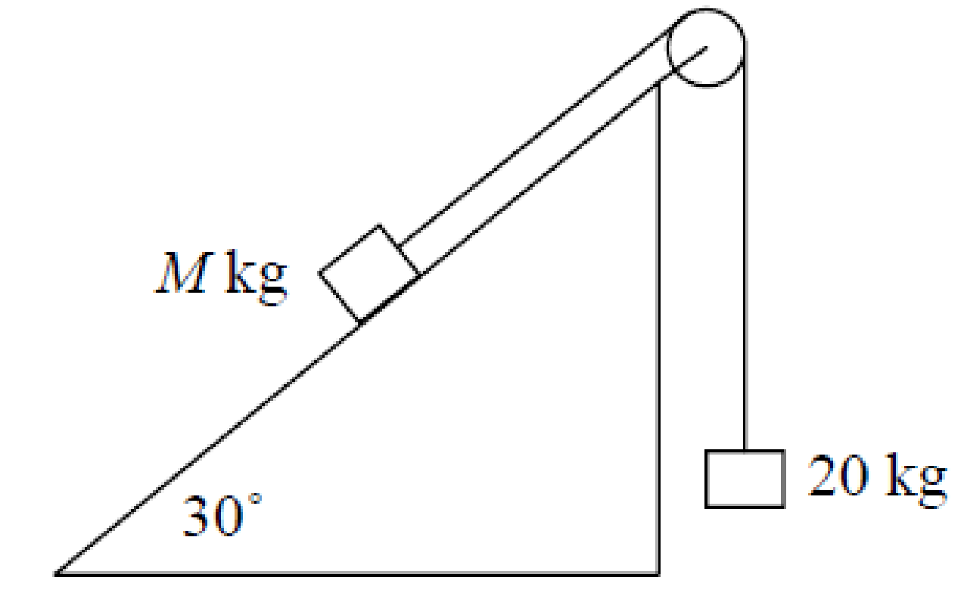
This particle is connected by a light inextensible string passing over a smooth light pulley at the top of the plane to a particle of mass 20 kg, hanging freely under gravity.
The coefficient of friction between the M kg mass and the plane is 2/(5√3).
The system is released from rest.
The 20 kg mass moves vertically upwards a distance of 16 m in 4 s.
- Show on separate diagrams all the forces acting on each particle.
- Show that the constant acceleration of the particles is 2 m/s².
- Find the tension in the string.
- Find the value of M.

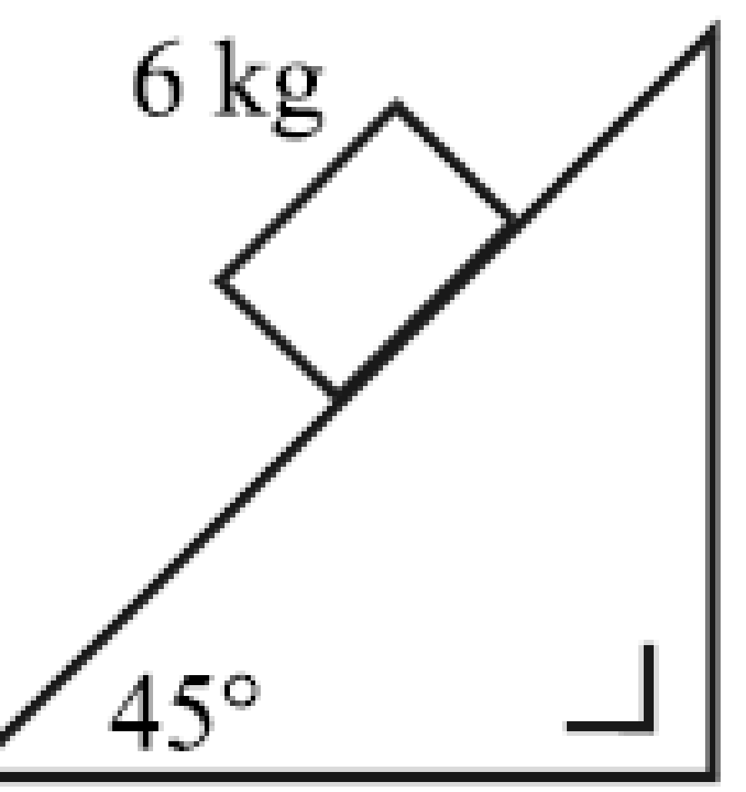
2004 (b) OL
A particle of mass 6 kg is placed on a rough plane inclined at an angle of 45° to the horizontal.
The coefficient of friction between the particle and the plane is µ.
The particle is released from rest and takes 4 seconds to move a distance of 10 √2 metres down the plane.
- Show on a diagram all the forces acting on the particle.
- Show that the acceleration of the particle is (5√2)/4 m/s².
- Find the value of µ.

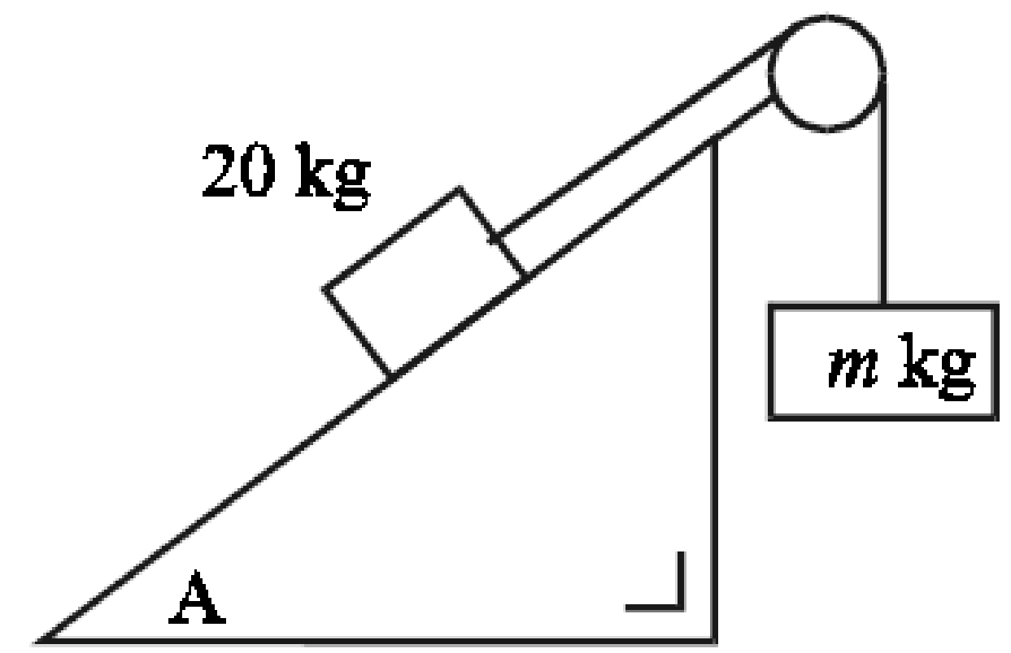
2001 (b) OL
A particle of mass 20 kg is placed on a rough plane inclined at an angle A to the horizontal where tan A = 3/4. This particle is connected by means of a light inextensible string passing over a smooth light pulley at the top of the plane to a particle of mass m kg, hanging freely under gravity.
The coefficient of friction between the 20 kg mass and the plane is 1/4.
The system is released from rest. The 20 kg mass moves up the plane.
The value of the tension in the string is 200 newtons.
- Find the common acceleration of the particles.
- Show that m = 25.

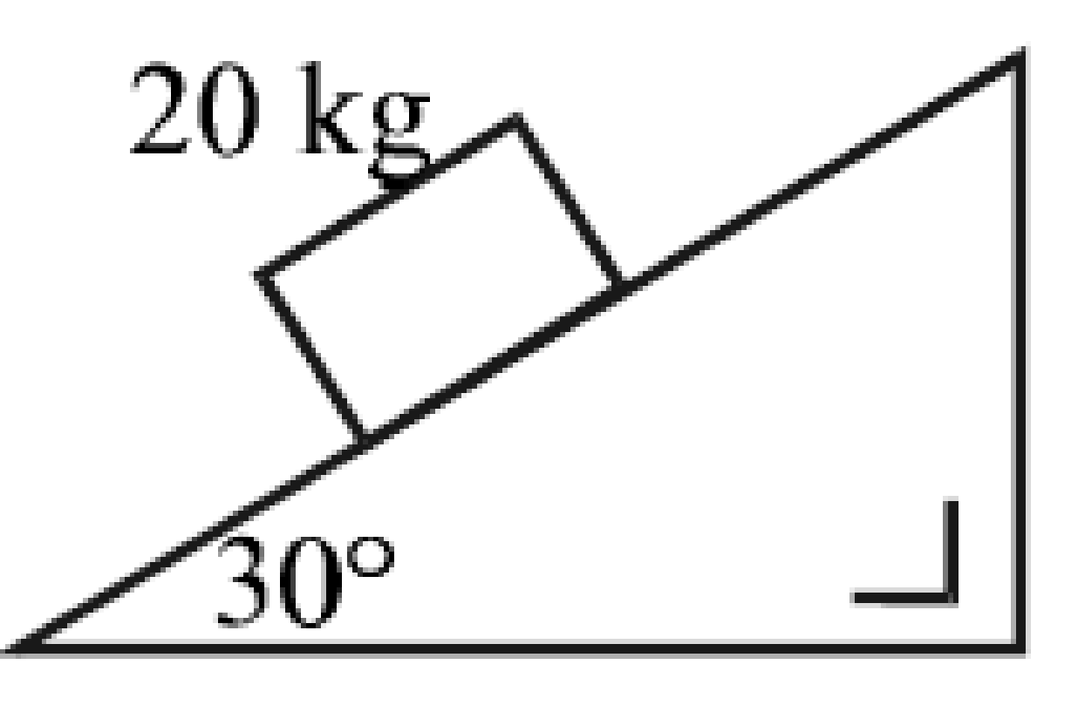
2000 (a) OL
A particle of mass 20 kg is placed on a rough plane inclined at an angle 30° to the horizontal.
The particle is on the point of moving down the plane.
- Show on a diagram all the forces acting on the particle.
- Find the value of μ, the coefficient of friction between the particle and the plane.

A smooth light pulley is now attached to the top of this plane.
A particle of mass m kg, hanging freely under gravity, is now connected to the particle of mass 20 kg by means of a light inextensible string passing over this smooth pulley at the top of the plane.
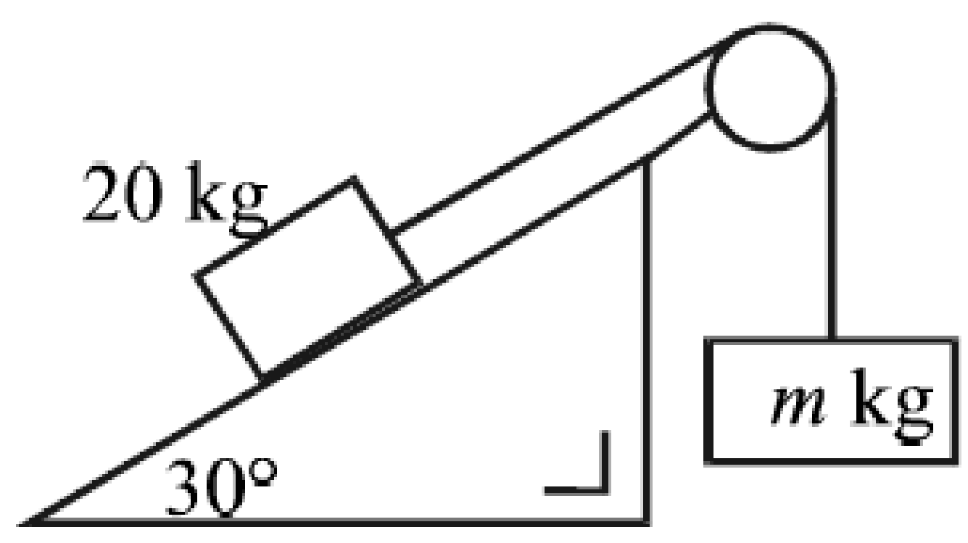
The particles are released from rest.
The 20 kg particle moves with an acceleration of 2 m/s² up the plane.
Find the value of m and the value of the tension in the string.

Wedges – Higher Level
2007 (a)
A particle slides down a rough plane inclined at 45° to the horizontal.
The coefficient of friction between the particle and the plane is ¾ .
Find the time of descending a distance 4 metres from rest.

2011 (a)
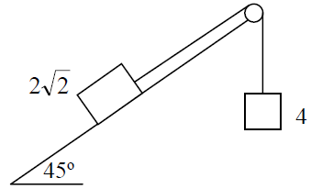
A block of mass 2$\sqrt{2}$ kg rests on a rough plane inclined at 45º to the horizontal.
It is connected by a light inextensible string which passes over a smooth, light, fixed pulley to a particle of mass 4 kg which hangs freely under gravity.
The coefficient of friction between the block and the plane is $\frac{1}{4}$.
Find the acceleration of the 4 kg mass.

1977
A mass of 2 kg is lying on a rough plane inclined at 60⁰ to the horizontal.
The coefficient of friction is ½.
The 2 kg mass is connected, by a light inelastic string passing over a smooth fixed pulley at the top of the plane, to a mass of 5 kg hanging freely.
When the system is set free the 5 kg mass moves downwards.
Show in separate diagrams the forces acting on each mass, and calculate the common acceleration.

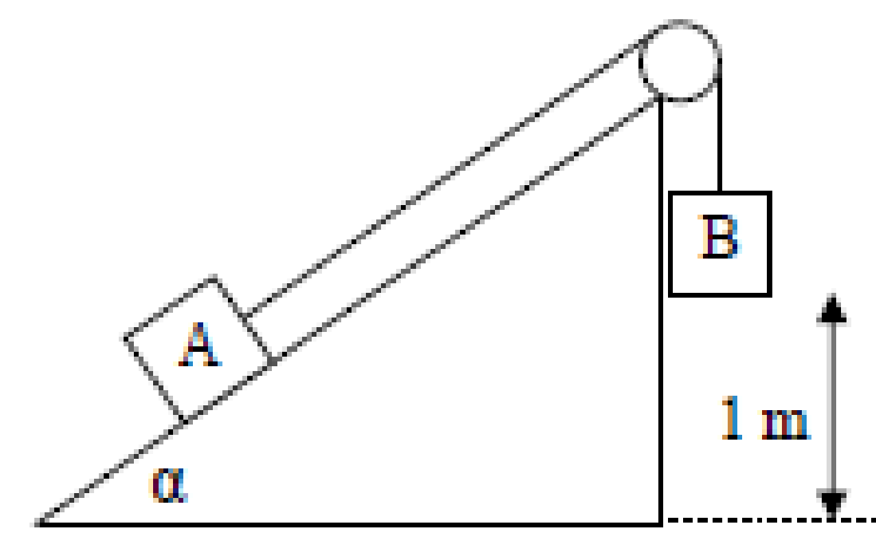
2012 (a)
Two particles A and B each of mass m are connected by a light inextensible string passing over a light, smooth, fixed pulley.
Particle A rests on a rough plane inclined at α to the horizontal, where $tantan α= \frac{5}{12}$

Particle B hangs vertically 1 m above the ground.
The coefficient of friction between A and the inclined plane is ½.
The system is released from rest.
- Find the speed with which B strikes the ground.
- How far will A travel after B strikes the ground?

2003 (b)
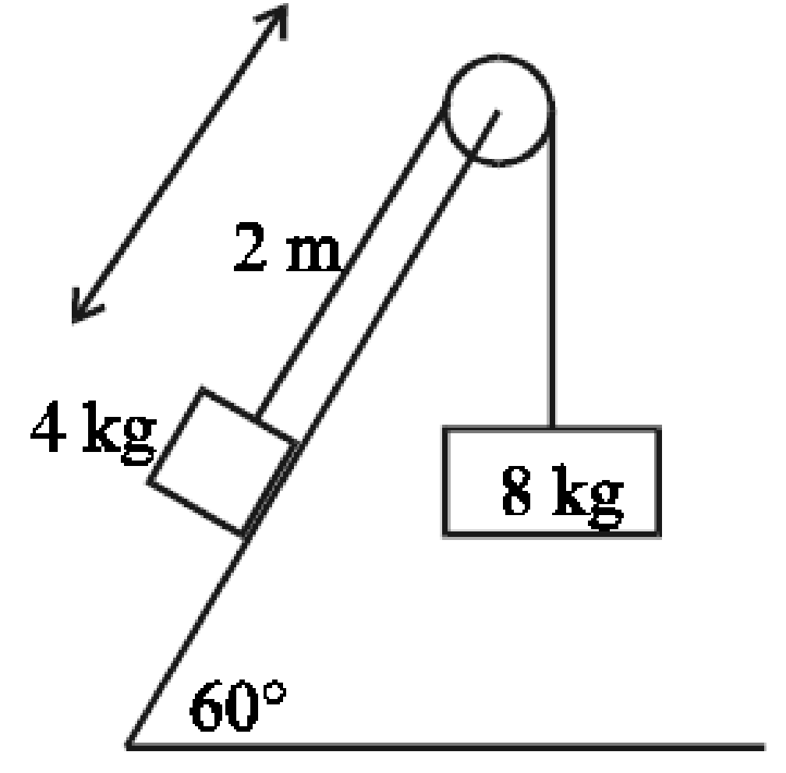
A block of mass 4 kg rests on a rough plane inclined at 60° to the horizontal.
It is connected by a light inextensible string which passes over a smooth, light, fixed pulley to a particle of mass 8 kg which hangs freely under gravity
The coefficient of friction between the block and the plane is ¼.
The system starts from rest with the block at a distance of 2 m from the pulley.
The 8 kg mass moves vertically downwards.
(i) Show that the tension in the string is 52 N, correct to the nearest whole number.
(ii) How far has the block moved up the plane after 1 second?
(iii) After 1 second the string is cut. Determine whether or not the block will reach the pulley.

2020 (a)
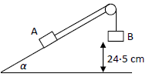
A block A of mass 10m on a smooth plane inclined at an angle α with the horizontal, where tan α = $\frac{3}{4}$, is connected by a light inextensible string which passes over a smooth pulley to a second block B of mass 10m.
B is 24.5 cm above an inelastic horizontal floor, as shown in the diagram.
The system is released from rest.

Find
- the acceleration of B
- the time that B remains in contact with the floor.

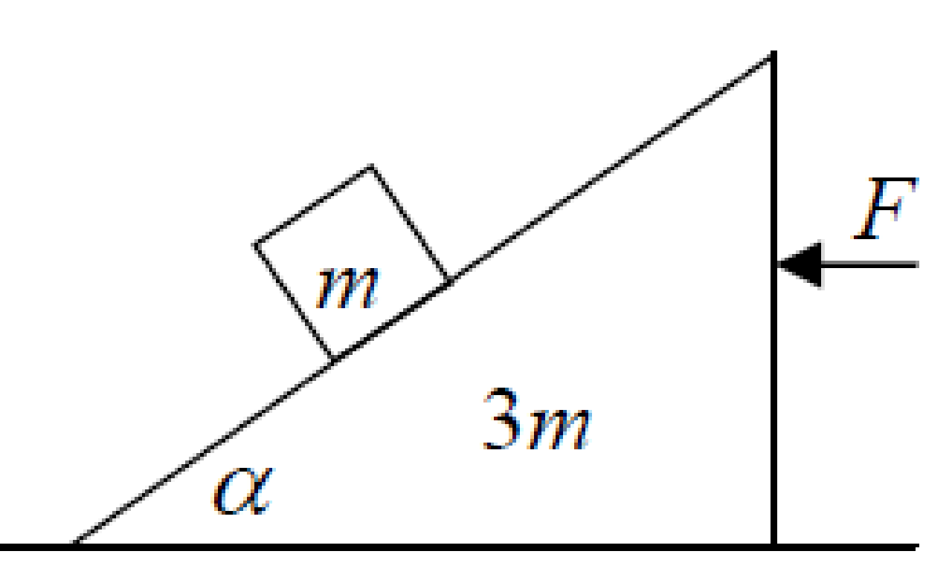
2006 (b)
A smooth wedge of mass 3m and slope α rests on a smooth horizontal surface.
A particle of mass m is placed on the smooth inclined face of the wedge and is released from rest.
A horizontal force F is applied to the wedge to keep it from moving.
(i) Show, on separate diagrams, the forces acting on the wedge and on the particle.
(ii) Prove that the reaction between the wedge and the horizontal surface is mg(3 + cos² α ).
(iii) If the speed of the particle after 1 s is 4.9 m/s, find the value of α.

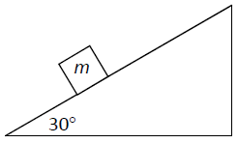
2021 (b)
A smooth wedge of mass 4m and slope 30° rests on a smooth horizontal surface.
A particle of mass m is placed on the smooth inclined face of the wedge and is released from rest.
A horizontal force F is applied to the wedge to keep it from moving.
- Show, on separate diagrams, the forces acting on the wedge and on the particle.
- Find F in terms of m.
{Part (iii) is no longer on the course so is not included}

2016 (a)
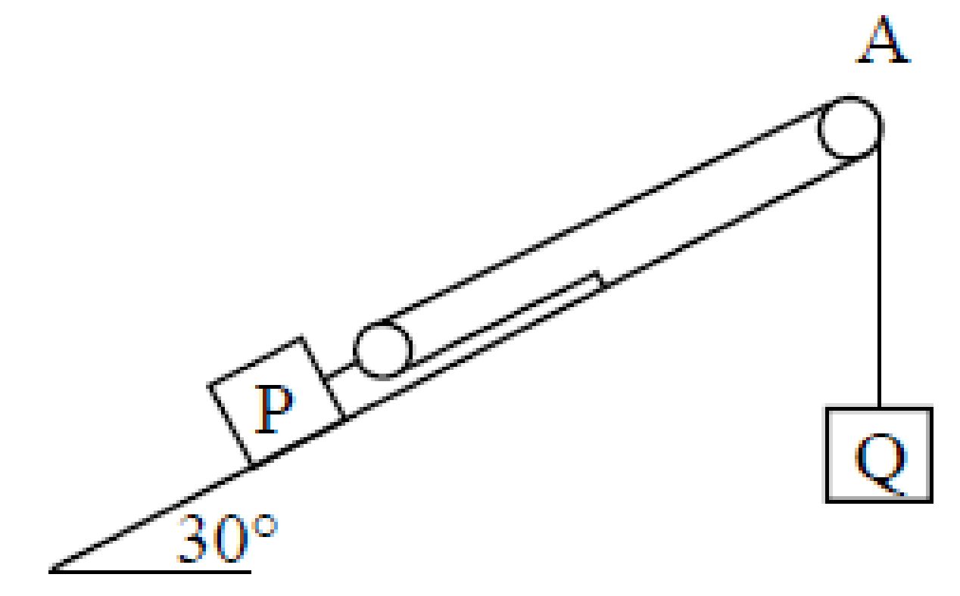
The block P has a light pulley fixed to it. The two blocks P and Q, of mass 40 kg and 30 kg respectively, are connected by a taut light inextensible string passing over a light smooth fixed pulley, A, as shown in the diagram.
P is on a rough plane which is inclined at 30° to the horizontal.
The coefficient of friction between P and the inclined plane is ¼.

Q is hanging freely. The system is released from rest.
- Find the acceleration of P and the acceleration of Q
- Find the speed of P when it has moved 30 cm.

2020 Question 4 (b)
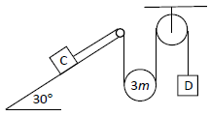
A particle C of mass 2m rests on a rough plane which is inclined at 30° to the horizontal.
The coefficient of friction between C and the plane is $\frac{\sqrt{3}}{21}$.
A light inextensible string which passes under a smooth movable pulley of mass 3m connects C to a particle D of mass m, as shown in the diagram.
The system is released from rest. C moves up the plane.

- Show, on separate diagrams, the forces acting on the moveable pulley and on each of the masses.
- Find in terms of m the tension in the string.

1994
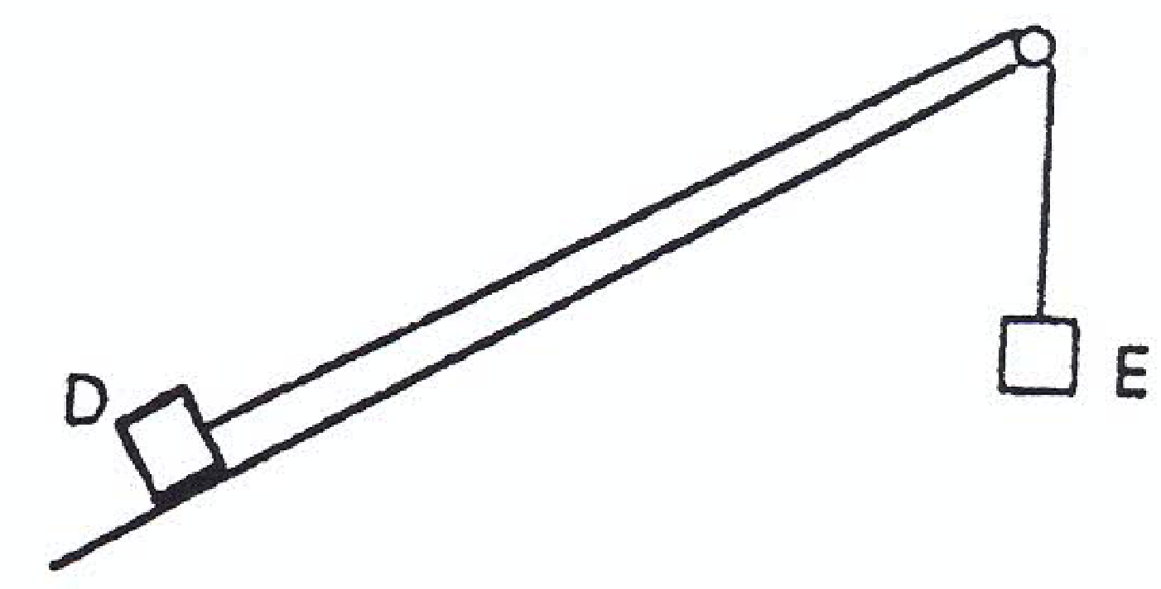
A particle D, of mass m, placed on a rough plane inclined at an angle of tan⁻¹ (5/12) to the horizontal, is attached to one end of an inextensible string.
The string passes over a small smooth pulley at the top of the plane.
An identical particle E hangs freely from the other end of the string.
The particles are released from rest.
The coefficient of friction, μ between D and the plane is ¹/₃.
- On separate diagrams show the forces acting on each particle and on the pulley.
- Find the tension in the string.
- The string broke after two seconds. Find the total distance travelled by D before coming to rest for the first time.

1991
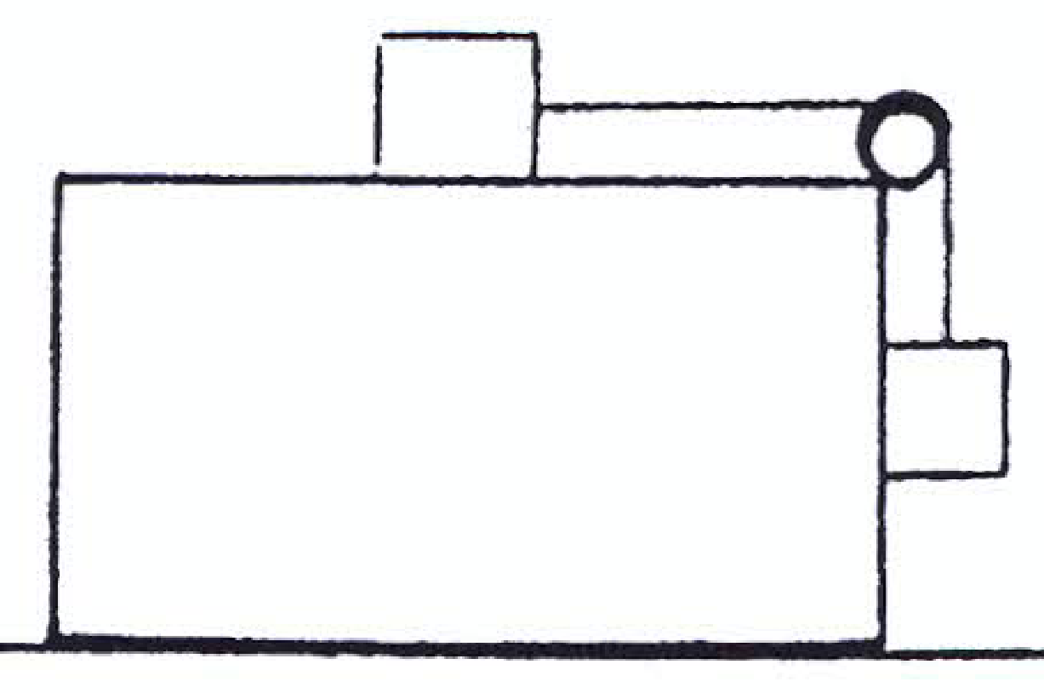
A rectangular block moves across a stationary horizontal surface with acceleration (g/3).
A particle of mass m, on the block, is connected by a string which passes over a light, smooth, fixed pulley to a second particle of mass m which presses against the block (see diagram).
- If contact between the particles and the block, is smooth, find the magnitude and direction of the resultant forces acting on the particles.
- If contact between the particles and the block, is rough, for what same value of the coefficient of friction, will the particles remain at rest relative to the block?

2015 (b)
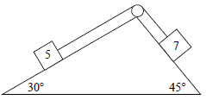
A wedge of mass 11 kg is held on the ground with its base horizontal and smooth faces inclined at 30° and 45° respectively to the horizontal.
A 5 kg mass on the face inclined at 30° is connected to a 7 kg mass on the other face by a light inextensible string which passes over a smooth light pulley.
The system is released from rest and the wedge does not move.
Find
- the acceleration of the particles
- the vertical force exerted on the ground.

2018 (a)
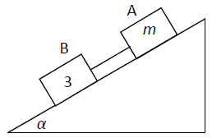
A block A of mass m is connected by a light inextensible string to a second block B of mass 3 kg.
They slide down a rough inclined plane which makes an angle α with the horizontal where tan α = $\frac{3}{4}$.
The string remains taut in the subsequent motion.
The coefficient of friction between A and the plane is $\frac{3}{4}$.
The coefficient of friction between B and the plane is $\frac{1}{3}$.
The system is released from rest.

- Find the acceleration of B, in terms of m
- Find the value of m if the tension in the string is 3·92 N.

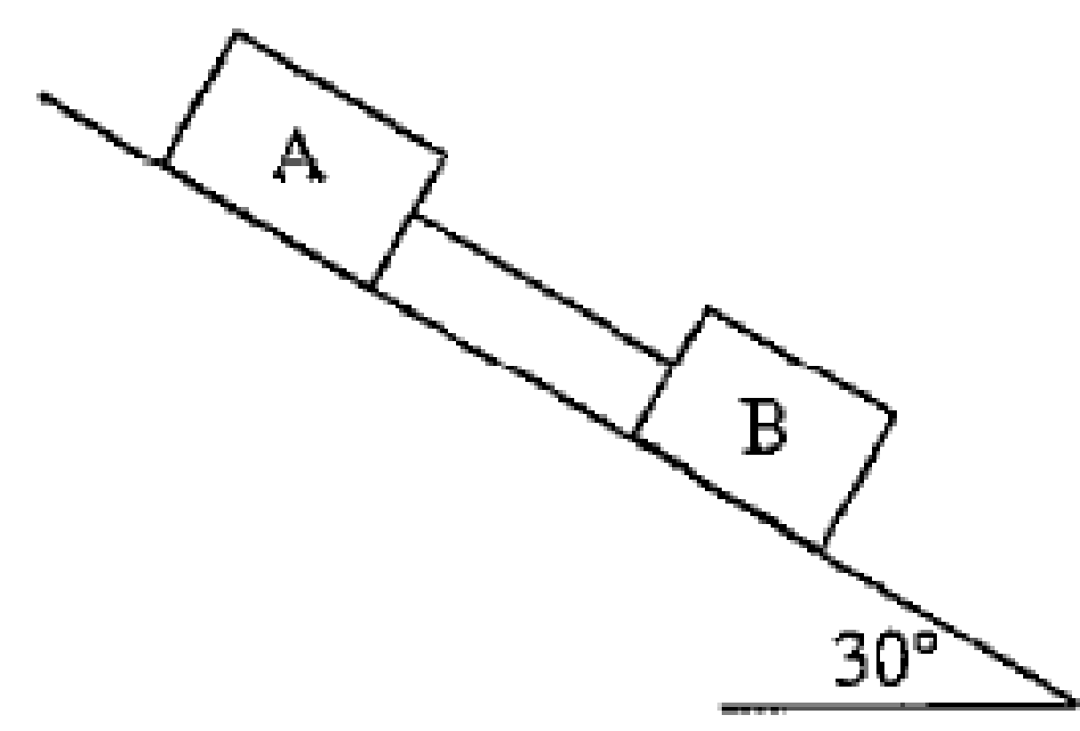
1998 (a)
Blocks A and B, of mass 15 kg and 25 kg, respectively, are connected by a light, inextensible string as shown in the diagram.
The coefficients of friction are 0.4 for block A and 0.2 for block B. the blocks move down the plane which is inclined at 30⁰ to the horizontal.
Find
(i) the acceleration of block B
(ii) the tension in the string

1985
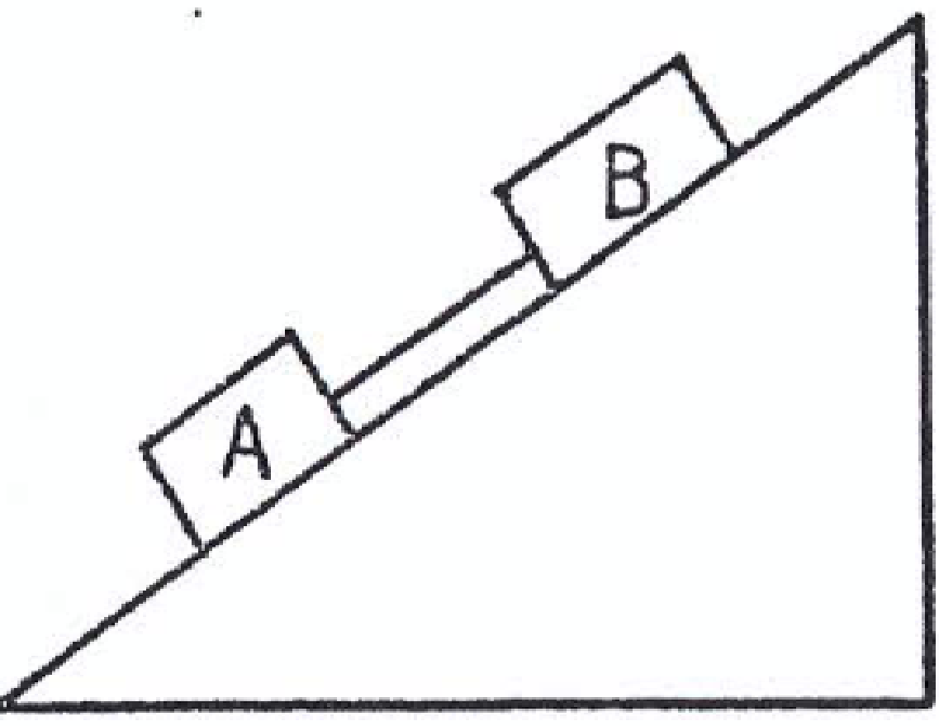
Two blocks A and B have masses 2 kg and x kg respectively.
They are connected by a string and slide down an inclined plane which makes an angle sin⁻¹(³/₅) with the horizontal.
The coefficient of friction between A and the plane is ¼ and between B and the plane is ½.
- Show on a diagram the forces acting on each block when the system is released from rest.
- Find the acceleration a of the system in terms of x.
- For what value of x would the acceleration of the blocks be 0.9a ?

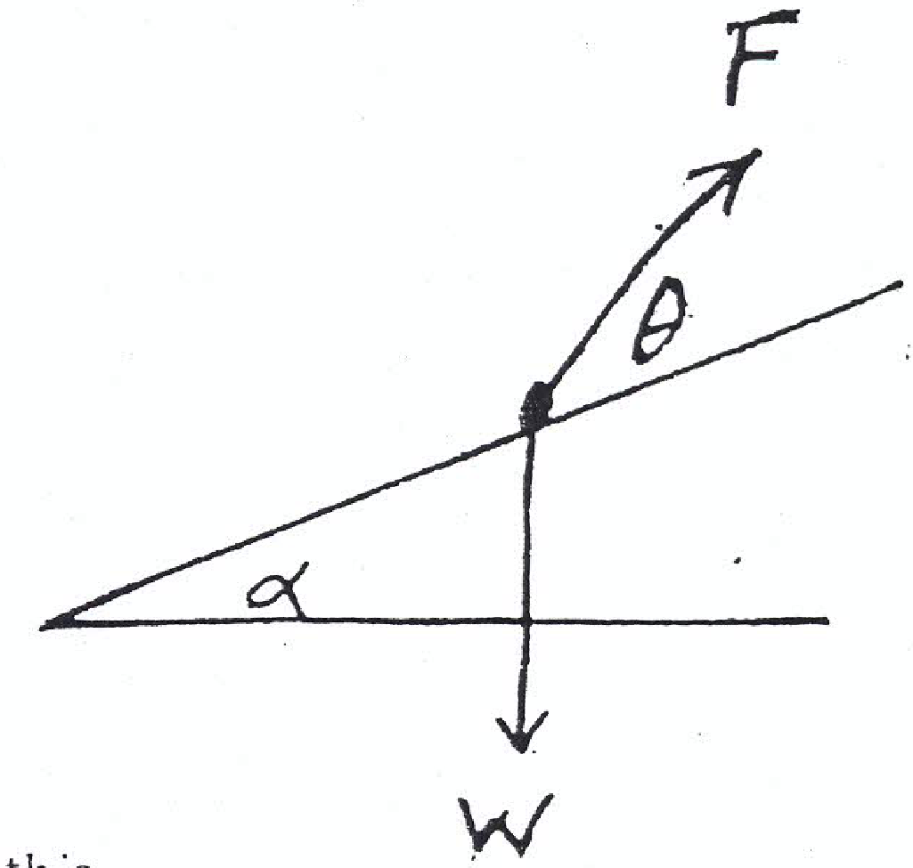
1980
State and prove the relationship between the coefficient of friction μ and the angle of friction λ.

The diagram shows a particle of weight W on a rough plane making an angle α with the horizontal.
The particle is acted upon by a force F whose line of action makes an angle θ with the line of greatest slope.
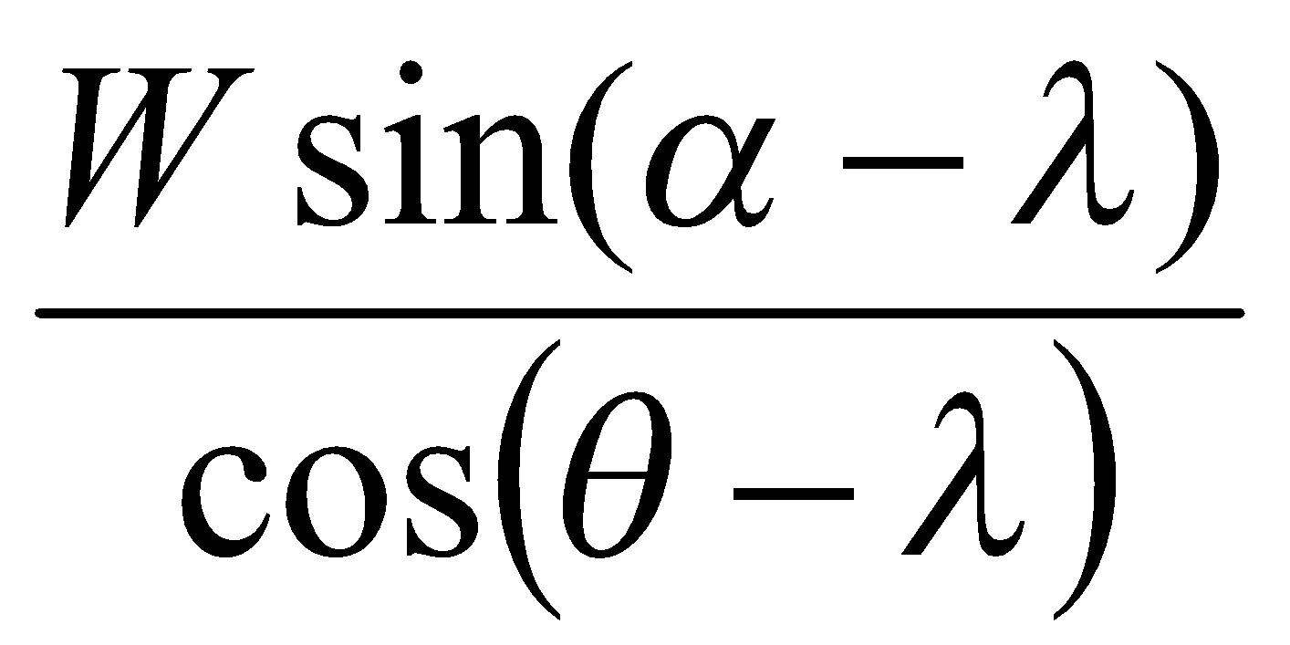
The particle is just on the point of moving up the plane.
- Draw a diagram showing the forces acting on the particle and prove that F =
If the particle is just on the point of moving up the plane, deduce
- the force acting up along the plane that would achieve this
- the horizontal force that would achieve it
- the minimum force that would achieve it.

Pulleys and Wedges: Answers to Ordinary Level Exam Questions
2017 (a)

- a = 1.25 m s⁻²
- T = 52.5 N
- No motion

2017 (b)
- a = 1.25 m s⁻²
- T = 33.75 N

2016 (a)
- a = 6 m s⁻²
- T = 16 N

2016 (b)

- a = 2.5 m s⁻²
- T = 74.4 N
- v = 3.6 m s⁻¹

2015 (a)

- a = 2.22 m s⁻²
- T = 38.9 N

2015 (b)
- a = 1.82 m s⁻²
- T = 98.2 N

2014 (a)
- a = 2.5 m s⁻²
- T = 37.5 N

2014(b)

- a = 2.5 m s⁻²
- T = 55 N

2013 (a)

- a = 4 m s⁻²
- T = 18 N

2013 (a)
- a = 1.25 m s⁻²
- T = 22.5 N

2012 (a)
- a = 2 m s⁻²
- T = 24 N

2012(b)

- a = 1.4 m s⁻²
- T = 42.9 N

2011(a)

- a = 15/4 m s⁻²
- T = 31.25 N

2011 (b)
- a = 2 m s⁻²
- T = 24 N

2010 (a)
- a = 1.67 m s⁻²
- T = 58.3 N

2010 (b)
- a = 5/9 m s⁻²
- T = 44.4 N

2009 (a)
- a = 4 m s⁻²
- T = 12 N

2009 (b)
- a = 5 m s⁻²

2008 (a)
- a = 2.86 m s⁻²
- T = 64.29 N

2008 (b)
- a = 1 m s⁻²
- T = 24 N
- μ = 0.7

2007 (a)
- a = 4 m s⁻²
- T = 42 N

2007 (b)

- a = 2 m s⁻²
- T = 24 N

2006 (a)

- a = 4 m s⁻²

2006 (b)
- a = 1 m s⁻²
- T = 18 N
- x = 18/11 kg

2005

- T = 240 N
- M = 240 kg

2004 (a)

- a = 6 m s⁻²
- T = 48 N

2004 (b)

- μ = 0.75

2003 (a)

- T = 90 N
- M = 15 kg

2003 (b)
u = 10 m s⁻¹

2002

- T₁ – 1/8(2g) = 2a
T₂ – T₁ – ¼(3g) = 3a
5g – T₂ = 5a
- a = 4 m s⁻²
T₁ = 10.5 N, T₂ = 30 N

2001 (a)

- T = 85 N
- μ = 5/12

2001 (b)
- a = 2 m s⁻¹

2000 (a)

- μ = 1/√3

2000 (b)
m = 30 kg, T = 240 N

Pulleys and Wedges: Answering Higher Level Exam Questions
2009 (a)
- Straightforward, v = 2.556 m s⁻¹.
- Straightforward, s = 1.33 m

2009 (b)
- Theory is straightforward but algebra is tricky, and it doesn’t help that the answer just looks wrong. Remember that the acceleration of C is (a + b) / 2.
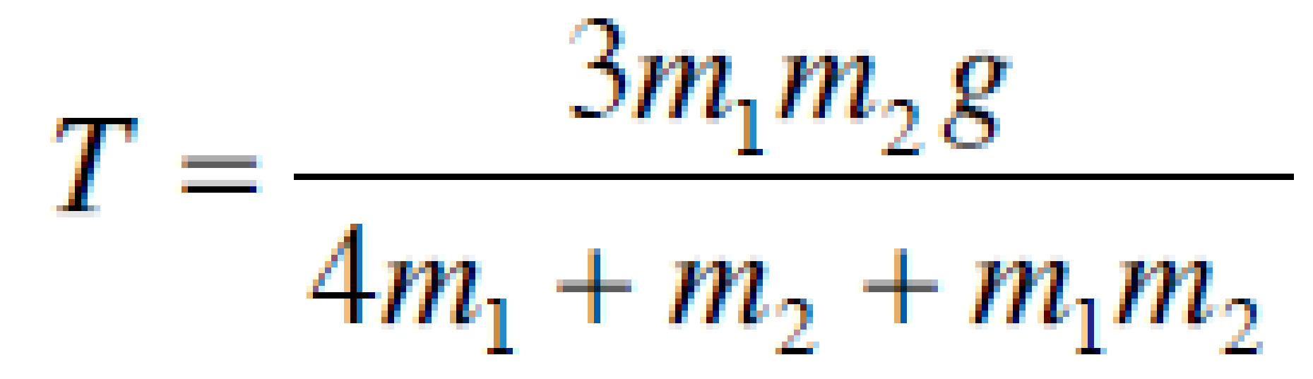
Answer:

- C will remain at rest if m₂g – 2T = 0. Sub in the value for T and have fun with algebra to get k = 1.

2008 (a)
Straightforward, note that if we make the upward acceleration of A to be f, then the downward acceleration of m₁ automatically becomes 2f.

2008 (b)
This was a testing question and a bit different from the standard. You had to understand the concepts rather than just remember the equations from previous questions. In particular you needed the break up the acceleration of the wedge into two perpendicular components twice (and into different directions each time).
Notice that they gave 30 marks for part (a) of this question, which was far easier, which would suggest to me that few people got part (b) correct and the marking scheme had to be adjusted accordingly. But I could be wrong ☺
- Remember that the pulley on top is part of the wedge and therefore the forces acting on this need to be included.
- The wedge is on a smooth surface so it will accelerate to the right (because the 2mg Sin ⎝ component in that direction is larger than the mg Sin ⎝ component acting in the opposite direction). If we call the acceleration of the wedge q, then for the 2m mass we need to break q up into components parallel and perpendicular to R₁, and for the m mass we need to break q up into components parallel and perpendicular to R₂ (where R₁ is associated with the 2m mass and R₂ is associated with the m mass).
There is still a bit of algebraic manipulation to be done. In relation to the particles you will need to use the equations relating to the forces perpendicular to the wedge surface, but you can ignore the equations for the masses parallel to the wedge surface.
Ans: q = (g√3)/19

2007 (a)
Easy peasy.
Acceleration down the slope = g/ (4√2)
Ans: t = 2.15 secs.

2007 (b)
- Straightforward.
- You can make the algebra much easier for yourself by having the 4 kg and the 6 kg masses both go the same way. In this case we will assume that they both go up and that the middle mass goes down.
Secondly you need to note that the 6 kg mass and the 4 kg mass will have different accelerations (even though they will both experience the same tension).
Finally you must use note that the acceleration of the movable pulley will be the half of the average of the other two.
Ans: T = (48mg)/ (5m + 48)
- Straightforward.

2006 (a)
- Easy peasy. a = g/9
- Linear acceleration-type question. Find out the speed of the 0.5 kg block when it hits the ground. This is now the initial velocity of the 0.4 kg block as it accelerates upwards at an acceleration of just g (let’s call this stage 2). This block will get to the top of its motion and then fall back down; when it gets to where it started stage two the string will again become taut, so really we just need to calculate how long it took to get from the beginning of stage two to the highest point. Then just multiply this time by two to get the total time for stage 2.
Ans: t = 0.30 seconds. Note that we had to give the answer to two decimal places.

2006 (b)
- Straightforward
- Here we need to use the fourth equation which we normally don’t bother with: R₂ = 3mg + R₁ Cos ⟨ and combine it with R₁ = mg Cos ⟨ to get the required expression.
- Straightforward. Ans: ⟨ = 30⁰.

2005 (a)
- Easy peasy. Ans: T = 10g/3
- Not easy if you hadn’t thought about it before. Note that they gave 20 out of 25 marks for the first easy peasy part of the question, suggesting that most messed up part two. Anyway, the pulley is being pulled both horizontally and downwards due to the tension in the string, so you need to find the magnitude of two perpendicular forces, each of magnitude T (where T 10g/3 from part one). Use Pythagoras to get the answer: F = 46.2 N. Strictly speaking you should also be including the angle as left 45⁰ down.

2005 (b)
- Not as simple as it seems. First draw a large diagram to help you visualise the situation. Then find the velocity of the 3 kg mass after falling 1.5 m. Now don’t make the mistake of assuming that both particles will now move at this velocity (of √3 g ms⁻¹). You need to apply conservation of momentum: the total momentum of both particles before must equal the total momentum of both particles after. Using this approach results in common final velocity of 3√(3g)/8 as required.
- Work out the acceleration as you would normally do, then apply the information to the appropriate vuast equation to show that s = 0.84, which is less than 1 m and therefore the 3 kg mass will not reach the table.

2004 (a)
- Easy peasy. Ans: a = g/3 m s⁻²
- Straightforward. Just use the formula v² = u² + 2as to get s = 3v²/2g and double this to get the total distance between both particles as s = 3v²/g.

2004 (b)
- Straightforward.
- Straightforward. Ans: The marking scheme gives the acceleration of the particle as = 14g/(11√2), and the acceleration of the wedge as = 3g/11, but as I understand it the question asks for the acceleration of the particle relative to the wedge, so it should be the first answer minus the second answer.
- Find t from the second part of the question, and apply it to the first part.
Ans: s= 0.3 m.

2003 (a)
Easy peasy. Ans: a = g/2 m s⁻².

2003 (b)
- Straightforward.
- Straightforward. First get acceleration = 3.3 m s⁻². Ans: s = 1.65 m.
- You need to remember tha there will be a minus acceleration due to gravity (g Sin 60) and a minus acceleration due to friction (g/8). Ans: v = 4.1 when s = 0.35 so yes the particle will reach the pulley.
2002 (a)
Part (a) was actually a Simple Harmonic Motion question; it was very nasty to stick this in where students were expecting a Pulleys-and-Wedges question.

2002 (b)
- Tricky. First you have to change the weights into masses by dividing by g.
Then you have to remember how to deal with the relative acceleration of the particles.
Then when you work out that the acceleration is g/4, you must remember to add the external acceleration of g/2 to it.
Ans: a = 3g/4.
- Not something we could come across often, so although it is straightforward some students may be thrown by it. Simply apply Force down – Force up = ma to work out R (which is the Force up that we are looking for).
Ans: R = 3 N

2001 (Full question)
- Straightforward
- Straightforward question involving relative acceleration.
Ans: f = 2g/13 and a = 5g/13. This is from the marking scheme. I would have thought that for the 2m and ma masses you would have had to go one step further and take both accelerations into account.
- Find t from the first statement (remember you will have to use the relative acceleration here) and use this to find s for the second statement.
Ans: s = 0.67 m.

2000 (a)
Straightforward.
a = g/4 and s = 4.9 m.

2000 (b)
- Straightforward.
- Straightforward.
- Straightforward. t = 5/g seconds and speed = 3√2 m s⁻¹.

1999 (a)
- Easy peasy.
Answer: a = 1.225 m/s²
- This is easy if you know what is being asked for; it’s not something that’s normally asked so I suspect that it would have thrown many students. The force between the mass and the pan is actually just the reaction force, so just use Force_{big} – Force_{small} = ma
Answer: R₁ = 2.205 N and R₂ = 3.43 N

1999 (b)
- Straightforward
- Straightforward
- Acceleration = 5.76 m/s²

1998 (a)
- Not too bad. Draw a diagram and put in all forces. Get equations for each block along the plane and perpendicular to the plane. Solve.
Answer: a = 2.556 m s⁻².
- Easy.
Answer: T = 15.91 N

1998 (b)
There is a very nasty part in here which (almost) everybody misses, so make sure you try the question yourself before checking the rest of this. Draw a free-body diagram for each block. A has three forces acting on it, while B has six. The force everybody forgets about is the 0.35 N acting on B in the opposite direction to P. This is due to Newton’s Law – for every action there is an equal and opposite reaction, so if A is exerting a force of 0.35 N on B, then B exerts and equal and opposite force on A.
Now simply work out equations for A and B in the vertical and horizontal directions to get the answer.
Answer: P = 350.35 N

1997 (a)
- Easy
Answer: a = 2g/(2 +m)
- Easy
Answer: m = 3 kg

1997 (b)
- Easy
- Straightforward, once you are familiar with the variation here. If C is going up with acceleration a then E must be going down with acceleration 2a.
- Easy

1996
Full question
Straightforward
Straightforward.
Answer: f = 0.34 m/s⁻², p = 2.4 m/s⁻²
Straightforward.
Answer: m = 3.9 kg

Pulleys & Wedges questions from 2023 and Sample Paper: Ordinary level and Higher level

Sample paper Ordinary Level Question 6
Block 𝐴, of mass 4 kg, rests on a rough horizontal table. It is connected to block 𝐵, of mass 6 kg, by a light inextensible string which passes over a fixed smooth pulley at the edge of the table.
When the system is released from rest, block 𝐴 is 40 cm from the pulley.
The coefficient of friction between block 𝐴 and the table is ½.

- Draw diagrams to show the forces acting on blocks 𝐴 and 𝐵 while they are moving.
- Calculate the frictional force acting on block 𝐴 while it is moving.
- Calculate the tension in the string and the acceleration of the blocks while they are moving.
- Calculate the speed of block 𝐴 when it reaches the pulley.
- Explain why it would not be appropriate to model this problem using the principle of conservation of energy.
2023 OL Question 9 (a)
A student models the motion of a car that is being driven on a rough straight horizontal road on a dry day in June. The car has a mass of 1200 kg. The student carries out some research and estimates that the coefficient of friction, 𝜇, between the car and the dry road is ¼.
The student also finds out that this car has a driving force (tractive force) of 6500 N.
The student models the motion of the car starting from rest.

- Calculate the force of friction that acts on the car while it is moving.
- Calculate the acceleration of the car.
- If the student modelled the motion of this car being driven on the same road in December, explain one refinement that the student might make to the mathematical model.

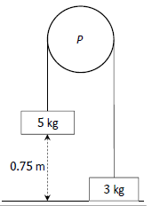
2023 OL Question 9 (b)
A fixed smooth pulley, 𝑃, has blocks of masses 5 kg and 3 kg hanging freely from either side. The blocks are connected by a light inextensible string which passes over the pulley 𝑃.
The 3 kg block is initially at rest on a smooth table and the 5 kg block is held at a distance of 0.75 m above the table, as shown in the diagram.
The system is then released from rest.
- Draw separate diagrams to show the forces acting on the blocks while they are moving.
- Calculate the acceleration of the system.
- Calculate the kinetic energy of the 5 kg block as it hits the table.

2023 HL Question 5 (a)
Block 𝑃 (of mass 6.3 kg) and block 𝑄 (of mass 2.5 kg) are held at rest on a rough surface.
They are connected by a light inextensible string which passes over a smooth fixed pulley.
Block 𝑄 lies on the horizontal part of the surface and block 𝑃 lies on the part of the surface that is inclined at 25° to the horizontal, as shown in the diagram.
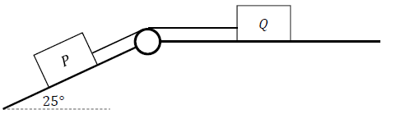

The coefficient of friction between each block and the surface is 0.2.
The blocks begin to move when they are released.
- Show, on separate diagrams, the forces acting on the blocks while they are moving.
- Calculate the acceleration of the blocks.

Sample Paper HL Question 7 (b)
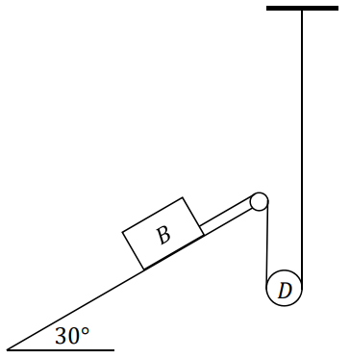
A small smooth moveable disk 𝐷, of mass 0.2 kg, rests on a light inextensible string. One end of the string is connected to block 𝐵, of mass 4 kg, which rests on a rough plane inclined at 30° to the horizontal.
The other end of the string is connected vertically to a fixed point.
The coefficient of friction between block 𝐵 and the inclined plane is $\frac{1}{10}$.
When the system is released from rest, 𝐷 moves upwards with acceleration 𝑎.
The tension in the string is 𝑇.
- Show, on separate diagrams, the forces acting on block 𝐵 and disk 𝐷 while they are moving.
- Explain why the acceleration of 𝐵 is 2𝑎.
- Calculate 𝑎 and 𝑇.

